Epsom & Ewell F.C.
21
v
AFC Hayes
Saturday, 28th April 2018 – 3.00 p.m.
Good afternoon and welcome to High Road for our final League match of the season against AFC Hayes. We welcome their players, supporters and officials and wish them a safe journey home, as of course we do for our own regular supporters.

We do not have a very good record against our opponents, losing on all but two occasions against them and never yet registering a home win, although we came close last year, leading 2-0 with twenty minutes remaining but having to settle for a 2-2 draw. It would be nice to end that particular run today, but the reality is that they are probably more desperate for points than we are now. Having faced the likelihood of relegation for most of the season we now know that we will be making the drop to Step Six. This is a desperately sad situation for our club, but some good may come of it if we can bounce straight back and build some momentum in the process.

We were last here on Tuesday 17th April when we met CB Hounslow United. Despite conceding twice around the half hour mark, we responded with two goals of our own in quick succession before half time and ran away with it in the second half by five goals to two!

Then two days later we made our longest journey of the season to Berkeley Fields, home of North Greenford United, another club that we have a poor record against, although we battered them in the first half and ended up four goals ahead at the break. Although there were no goals after the break, the final score of 4-0 was also good enough to take us off the bottom of the table.

Finally, on Tuesday we made our first ever visit to the Elmbridge Sports Hub where we met Walton & Hersham and came up against a very powerful and pacey team that beat us 4-0 on the night and it could have been worse. Still, seven points from our last twelve is respectable!

We have Player of the Year forms available at today’s match and all supporters are entitled to a vote. If you are a Club Member your vote counts for double points, so let us have your 1-2-3!!

As it is our final match of the season we have our summary programme today, covering a seasonal recap for those of you who want to revisit our last nine months. Additionally, a long running item, the A-Z completes today. It first appeared on 14th August 2010 when we hosted Shoreham at Merstham F.C. in an F.A. Cup tie and has continued pretty much ever since. Finally it is finished!

I hope you all have a great summer break and enjoy the England matches at the World Cup (Quarter-Finals by the way, you heard it here first!) and return to following the Salts next year when Operation Bounceback will be in operation. We will need your help and we also should also have some news on the ground front. Fingers crossed that it is good news!

Enjoy the game and the summer!

Rich

Don’t forget, you can now follow us on Social Media. Please see the inside cover for addresses.

Cover photos by Gemma Jarman

1) Joe Loftus-Cheek scores our opening goal at home to Westfield two weeks ago today
2) Joe is there again to drive in a loose ball for our equaliser in that 2-2 draw
1

Cherry Red Records Combined Counties League
Premier Division Table 2017/18
inc Tuesday 24th April | P | W | D | L | F | A | Pts | GD | H | A
Westfield © | 40 | 34 | 3 | 3 | 143 | 40 | 105 | +103 | 2-2 | 0-5
Bedfont Sports | 40 | 28 | 6 | 6 | 101 | 54 | 90 | +47 | 2-4 | 0-7
Sutton Common Rovers | 39 | 27 | 4 | 8 | 90 | 44 | 85 | +46 | 0-2 | 0-5
Walton & Hersham | 40 | 25 | 6 | 9 | 84 | 50 | 81 | +34 | 0-2 | 0-4
Redhill | 41 | 20 | 5 | 16 | 82 | 63 | 65 | +19 | 0-5 | 0-3
Camberley Town | 41 | 14 | 20 | 7 | 53 | 41 | 62 | +12 | 0-0 | 1-1
Balham | 36 | 18 | 6 | 12 | 72 | 55 | 60 | +17 | 0-2 | 0-4
CB Hounslow United | 37 | 17 | 5 | 15 | 71 | 59 | 56 | +12 | 5-2 | 2-4
Knaphill | 39 | 15 | 11 | 13 | 70 | 62 | 56 | +8 | 0-0 | 2-6
Spelthorne Sports | 41 | 16 | 8 | 17 | 67 | 65 | 56 | +2 | 1-5 | 0-0
Hanworth Villa | 40 | 15 | 9 | 16 | 65 | 77 | 54 | -12 | 1-1 | 3-2
Guildford City | 40 | 15 | 7 | 18 | 68 | 83 | 52 | -15 | 1-3 | 3-4
Horley Town | 40 | 15 | 7 | 18 | 57 | 80 | 52 | -23 | 2-3 | 2-3
Abbey Rangers | 38 | 11 | 11 | 16 | 53 | 58 | 44 | -5 | 1-1 | 0-0
Colliers Wood United | 38 | 13 | 4 | 21 | 64 | 68 | 43 | -4 | 0-1 | 2-5
North Greenford United | 36 | 11 | 10 | 15 | 54 | 65 | 43 | -11 | 1-2 | 4-0
Chertsey Town | 39 | 12 | 6 | 21 | 62 | 83 | 42 | -21 | 2-7 | 0-1
Banstead Athletic | 39 | 11 | 7 | 21 | 52 | 91 | 40 | -39 | 2-2 | 1-1
AFC Hayes | 37 | 11 | 6 | 20 | 50 | 75 | 39 | -25 | 28/4 | 0-2
Godalming Town | 37 | 8 | 6 | 23 | 46 | 83 | 30 | -37 | 0-3 | 2-1
Epsom and Ewell | 41 | 5 | 11 | 25 | 45 | 105 | 26 | -60 | X | X
Farnham Town | 41 | 5 | 10 | 26 | 47 | 95 | 25 | -48 | 3-0 | 0-0

Lucky Day? – 28th April
Played 21 - Won 9 Drawn 4 Lost 8 - For 43 Against 33 - PPG 1.48 - Average
Our Club record against AFC Hayes
Played 10 - Won 2 Drawn 3 Lost 5 - F 18 A 19 - PPG 0.90 - Poor
Largest wins and losses against AFC Hayes
12th April 2016 - W 7-0 - Combined Counties League (A)
29th January 2005 - L 0-3 - Isthmian League Division Two (H)
AFC Hayes‘ Last Visit
Saturday 26th November 2016 - Drew 2-2 - Combined Counties League

Club President – Stella Lamont
Good Afternoon Everyone,

In the year when three schoolboys decided to form a football team at the end of their club’s debut cricket season there were Zeppelins in the sky above England and milk was delivered door-to-door on a cart drawn by a horse. A hundred years later the Zeppelins and cart-horses may have gone but our football club, born in the shadows of the First World War remains.

Although we take a step down next season to play our fixtures in a different division we can only be encouraged by the way this season has ended: clean-sheets, goals galore, matching some teams and beating others. It has been a marvellous collective response by our players and management - a mini-season of success - and has rewarded one teetering near-nonagenarian no end.

I was born a little less than ten years after the end of one World War and a little more than ten before the beginning of another. We can perhaps imagine the beady eye of a soaring bird up among the clouds and vapour trails spying me below as I crossed London bridges after work to watch football at professional grounds, or taking trams and trolleybuses to outlying destinations, or Green Line coaches that wound through leafy Surrey lanes to places that became familiar across the years as my love of semi-professional football deepened and my involvement with Epsom grew.

I travelled by club coach and in the passenger seat of cars to matches home and away season after season. I’ve been a football fan for almost as long as I can remember and never throughout my ninety years has my heart not lifted at the thought of following my team.

Now humbled in my armchair, unable to travel anywhere, but still thankful for the many friends I made watching Epsom across the years, I follow my club on the internet and the progress of our matches on Twitter. Who would have thought it? Don’t doubt my commitment!

So here we are at the season’s end, and already thinking the cricket can’t stop soon enough for the next to begin. Step Four, Step Five, Step Six? No matter, step forward! It’s all opportunity. Give me another ten years and I’ll cheer us on to Step One!

Stella

Club Chairman – Pete Beddoe
Good afternoon to all our supporters. I just thought I’d let you know my perspective of this season, our need to be positive for next season, and the long term survival of our Club.

After a very successful season in 2016-17 we were fully confident that this season would be as successful. However, we never recovered from the loss of the bulk of our team to our near neighbours and rivals Sutton Common Rovers FC (SCR FC). We also lost our Coach which left a hole in our Management Team.

Glyn Mandeville had little time to recruit a new squad of sufficient strength to compete at our level. It was a blend of young inexperienced and some more experienced players who had played for us previously. Unfortunately the blend didn’t work and many of the more experienced players often had work commitments on match days and weren’t available. To say the least we started off badly and never really recovered. There were one or two highlights, principally a 7-2 win at Rusthall in the Vase where Reisse Griffin ran straight through the opposition ranks for a good 70 yards before slotting the ball past their keeper. Another highlight, and giving us great pleasure and poetic justice, was a win on penalties away to SCR FC in the Surrey Senior Cup ; Conor Young turning away one of their attempts and Lloyd Connelly securing the win with his penalty.

Before Christmas we secured the services of Neil Grant, who’d had experience at Leatherhead FC & Guildford City FC and a good working relationship between him and Manders was soon achieved and performances did improve on the pitch. First the defence was shored up and now we are increasingly improving in attack. Neil is developing a good rapport with the players and between the players. It is good to see the momentum continuing to increase with our recent excellent performances. It is important we continue to support both on and off the pitch.

However it was clear that Manders was getting increasingly frustrated trying to fit in his football duties with a heavy workload often necessitating shift work and he decided to resign after the Godalming away match in early January. He bowed out though with a good win against them which pleased everybody. Manders had been a loyal servant of the Club over a number years and will be remembered fondly.

Neil took over the reins as Caretaker Manager and soon lost the Caretaker handle. Our performances continued to improve, with the defence getting really tight. The trouble was we just couldn’t get the ball in the net. As I think I’ve said before, they took to heart the instruction from Bretty the groundsman at Chipstead not to use the goal mouth during the final warm up on the pitch and continued to carry on

with this instruction when the match started! As you can see this has now been rectified and we are now scoring goals.

We are progressing with our attempt to relocate our Club back to the Borough to a site which strongly suggests a sporting association! The next step, after a preliminary presentation of our Vision of part of this site which was well received by the Residents’ Association Group of Councillors, is for it to be discussed by them at their meeting in mid-May where we’ve been promised it will be at the top end of their Agenda.

We have to be patient and not push them too hard. The aim will be to keep the discussion continuing, whilst emphasizing that time is the essence. We have kept Chris Grayling MP, the Club’s Patron, fully informed of our plans and he is very supportive. If anyone has any queries or suggestions please let me know. The Club has survived 100 years and we are attempting to survive another 100 years. It is imperative that we relocate within the Borough for our continued existence.

As you all know, this year is the Centenary of our Club and this is being publicised in the press and on our website. As part of our celebration we are holding a special event to celebrate this at Epsom Golf Club on Saturday 8th September. I’d ask everybody to support this event; further details will be posted on the website.

I’d like to thank everyone at Chipstead for ensuring that we were well looked after on match days. A special word to Levent who looked after the Bar and to wish him well for the future, Bretty who painstakingly provided our excellent pitch, Simon who co-ordinated matters behind the scenes, Terry for all the odd jobs & moral support and of course not forgetting Heather who liaised with all the administration matters. Karen has provided tasty sandwiches and Mustafa continues to provide his excellent laundry service of the kit.

I’d like to thank all the members of the Committee, Steve, Richard, Paul, Mel & Gary for all their hard work during the season, irrespective of the results on the pitch. A personal word to Paul for ensuring I always arrive on time for matches and of course congratulations on his recent promotion to the Bench. Also many thanks to George who provided excellent match reports in the local press. Finally, but not least a special word of thanks to Gemma our loyal Club photographer who comes to our matches whatever her personal circumstances and the weather.

The Committee would like to thank Neil, and his team, for all their hard work during this difficult season and our loyal band of supporters for their support through thick and thin.

Trusting that we all have a relaxing break now, keeping fit of course, and coming back refreshed and with a good team spirit ready for next season, which is never far away!

Pete

Club Manager – Neil Grant
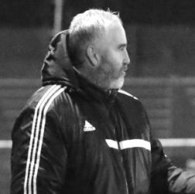
Good afternoon to all our supporters for today’s final game of the season and also welcome all those involved with AFC Hayes.

Since my appointment as First Team manager in January 2018, the Salts fans and Committee members have been superb in supporting myself and the team and I’m greatly thankful for their support.

I know how disappointed everyone will be but unfortunately we finally ran out of time to turn things around. Having said that I’m still pleased with how things have gone since my appointment and in recent weeks the lads have shown what they are capable of and the notable performances against Westfield, CB Hounslow United and North Greenford United.

Like I said in previous weeks the lads have really taken to my ideas and philosophy and it’s pleasing to see notable performances on the pitch which I believe shows that these group of players care.

Having said that I was always brought up to believe that football doesn’t stand still for anyone and I’m already working towards next season as I believe with this group of players we will be stronger and better and challenging to winning titles again.

To prepare for next season I believe that to be successful we need to have a good pre-season and commitment from players and today I’m hopeful we will be able to announce players we will retain for 2018/19.

Training will start in first week of July and Knaphill and Guildford City are already confirmed for friendly fixtures with possible Bostik League opponents to be announced shortly, so there is plenty to look forward to, as I believe while I’m at Epsom and Ewell the future is a bright one as long as everyone believes and trusts in the philosophy that I believe in.

I’m hopeful that working closer with the Colts in the future will only make the Salts a stronger club with the community and is one I’m looking forward to.

Massive thanks to all those volunteers that make game-day possible, but I personally would like to thank everyone that has made me feel welcome since I joined as first team coach in November 2017.

Finally, these may be seen as low times at Epsom and Ewell by most, but I see this as only the beginning of a new future and we must all work together for the FUTURE of the club.

Neil

First Eleven Appearances 2017/18 - (max 47)
Name | Debut | 2017/18 |  |  |  | Career Totals
 |  | App | Sub | Tot | Goals | App | Sub | Tot | Goals
AJAYI Tayo* | 06/08/2017 | 3 | 4 | 7 | 1 | 3 | 4 | 7 | 1
ANDERSON Miguel | 03/02/2018 | 4 | 2 | 6 | 0 | 4 | 2 | 6 | 0
BROOKS Jordan* | 06/08/2017 | 3 | 0 | 3 | 0 | 3 | 0 | 3 | 0
BURROWES Joshua* | 02/12/2017 | 1 | 1 | 2 | 0 | 1 | 1 | 2 | 0
CASTELL Cristian* | 06/08/2017 | 2 | 4 | 6 | 0 | 2 | 4 | 6 | 0
CAULCRICK Joshua | 17/02/2018 | 0 | 1 | 1 | 0 | 0 | 1 | 1 | 0
CLARK Jordan* | 17/02/2018 | 0 | 2 | 2 | 0 | 0 | 2 | 2 | 0
CONNELLY Lloyd | 14/10/2017 | 29 | 4 | 33 | 2 | 29 | 4 | 33 | 2
DEWAR Ali* | 29/10/2011 | 1 | 2 | 3 | 0 | 56 | 42 | 98 | 10
DOBRAJ Endrit | 18/11/2017 | 18 | 4 | 22 | 0 | 18 | 4 | 22 | 0
DYSON Ben | 12/08/2017 | 27 | 13 | 40 | 2 | 27 | 13 | 40 | 2
FRANKLIN Ben | 03/03/2015 | 3 | 1 | 4 | 0 | 4 | 1 | 5 | 0
GRAHAM Bentley* | 09/02/2016 | 3 | 0 | 3 | 0 | 20 | 1 | 21 | 3
GRANDISON Kane* | 11/11/2017 | 7 | 1 | 8 | 0 | 7 | 1 | 8 | 0
GRIFFIN Reisse | 08/08/2015 | 30 | 0 | 30 | 2 | 103 | 13 | 116 | 8
HARLAND-GODDARD Tom* | 06/08/2017 | 1 | 1 | 2 | 0 | 1 | 1 | 2 | 0
HARRIS Colin* | 04/08/2012 | 9 | 0 | 9 | 0 | 34 | 0 | 34 | 0
HATFIELD Jamie* | 11/11/2006 | 9 | 1 | 10 | 0 | 258 | 14 | 272 | 6
HAYWARD Ben* | 07/03/2007 | 5 | 1 | 6 | 0 | 248 | 29 | 277 | 18
HEAGNEY Adam | 16/08/2016 | 30 | 3 | 33 | 1 | 67 | 12 | 79 | 2
HENDRY Rob* | 08/08/2015 | 16 | 1 | 17 | 5 | 84 | 23 | 107 | 28
HOUGH Kyle* | 14/08/2007 | 10 | 2 | 12 | 6 | 343 | 21 | 364 | 207
JASPER Joe* | 11/11/2017 | 0 | 1 | 1 | 0 | 0 | 1 | 1 | 0
JEANNOEL Germaine | 02/12/2017 | 2 | 7 | 9 | 1 | 2 | 7 | 9 | 1
KENNEDY Calum | 18/11/2017 | 2 | 1 | 3 | 0 | 2 | 1 | 3 | 0
LAW Franky* | 06/08/2017 | 3 | 0 | 3 | 0 | 3 | 0 | 3 | 0
LOFTUS-CHEEK Joe | 06/08/2017 | 14 | 7 | 21 | 6 | 14 | 7 | 21 | 6
MACAULEY Alvin | 10/03/2018 | 0 | 2 | 2 | 0 | 0 | 2 | 2 | 0
MARKS Samuel* | 06/01/2018 | 1 | 2 | 3 | 0 | 1 | 2 | 3 | 0
MARVELL Dale* | 15/01/2000 | 17 | 2 | 19 | 0 | 286 | 51 | 337 | 86
MASTERSON Shaun | 25/11/2017 | 10 | 3 | 13 | 0 | 10 | 3 | 13 | 0
MCKAY Alex | 20/12/2008 | 30 | 2 | 32 | 1 | 161 | 39 | 200 | 13
MULLINGS Corey* | 23/12/2017 | 0 | 2 | 2 | 0 | 0 | 2 | 2 | 0
MURPHY George* | 19/03/2013 | 2 | 0 | 2 | 0 | 70 | 7 | 77 | 3
MURPHY Scott | 20/01/2007 | 34 | 0 | 34 | 3 | 46 | 2 | 48 | 4
MYERS Antony* | 23/12/2006 | 1 | 0 | 1 | 0 | 76 | 33 | 109 | 9
NICHOLAS Kyen | 13/01/2018 | 12 | 2 | 14 | 7 | 12 | 2 | 14 | 7
NWACHUKWU Jason* | 01/10/2016 | 9 | 4 | 13 | 2 | 26 | 20 | 46 | 3
O'BRIEN Louis | 28/08/2017 | 5 | 6 | 11 | 2 | 5 | 6 | 11 | 2
PINDER Marlon | 13/01/2018 | 12 | 1 | 13 | 2 | 12 | 1 | 13 | 2
ROBERTS Liam | 12/08/2017 | 21 | 13 | 34 | 5 | 21 | 13 | 34 | 5
ROBINSON Sam* | 22/10/2011 | 5 | 0 | 5 | 0 | 66 | 6 | 72 | 14
ROSE Daniel* | 25/10/2016 | 14 | 2 | 16 | 1 | 16 | 7 | 23 | 1
RUSSELL Stuart | 30/03/2018 | 1 | 1 | 2 | 0 | 1 | 1 | 2 | 0
SAMPAT Mohammed* | 23/12/2017 | 3 | 0 | 3 | 0 | 3 | 0 | 3 | 0
SELLICK Rory | 27/01/2018 | 6 | 1 | 7 | 1 | 6 | 1 | 7 | 1
SMITH Andy* | 25/08/2017 | 2 | 0 | 2 | 0 | 2 | 0 | 2 | 0
SMITH Taryn | 28/10/2017 | 8 | 4 | 12 | 0 | 8 | 4 | 12 | 0
STEW-LEWIS Noah | 09/12/2017 | 6 | 2 | 8 | 0 | 6 | 2 | 8 | 0
THOMPSON Ashley | 21/08/2017 | 34 | 1 | 35 | 5 | 34 | 1 | 35 | 5
THOMPSON Elliott | 09/02/2016 | 3 | 0 | 3 | 0 | 10 | 9 | 19 | 1
THOMSON David* | 02/09/2017 | 2 | 2 | 4 | 0 | 2 | 2 | 4 | 0
TURPIE Ali | 31/03/2016 | 1 | 0 | 1 | 0 | 12 | 1 | 13 | 0
WHITE Sean | 02/08/2014 | 14 | 7 | 21 | 2 | 20 | 20 | 40 | 5
YOUNG Conor | 07/03/2015 | 32 | 0 | 32 | 0 | 33 | 0 | 33 | 0

Remaining Results and Fixtures
Combined Counties League – Tuesday 17th April 2018
AFC Hayes | 1-3 | Chertsey Town
Banstead Athletic | 3-1 | Redhill
Epsom & Ewell | 5-2 | CB Hounslow United
Hanworth Villa | 2-0 | Godalming Town
Knaphill | 1-2 | Guildford City
North Greenford United | 0-0 | Abbey Rangers
Westfield | 1-2 | Balham
Combined Counties League – Wednesday 18th April 2018
Colliers Wood United | 1-2 | Horley Town
Combined Counties League – Thursday 19th April 2018
Balham | 0-1 | Hanworth Villa
North Greenford United | 0-4 | Epsom & Ewell
Combined Counties League – Saturday 21st April 2018
AFC Hayes | 2-3 | Walton & Hersham
Balham | 0-2 | Camberley Town
Banstead Athletic | 3-1 | Farnham Town
CB Hounslow United | 1-4 | Colliers Wood United
Chertsey Town | 2-0 | Horley Town
Guildford City | 1-2 | Spelthorne Sports
Hanworth Villa | 2-1 | Abbey Rangers
Redhill | 1-0 | Knaphill
Sutton Common Rovers | 1-0 | North Greenford United
Westfield | 1-1 | Bedfont Sports
Combined Counties League – Monday 23rd April 2018
Balham | 4-0 | North Greenford United
Combined Counties League – Tuesday 24th April 2018
AFC Hayes | 0-2 | Bedfont Sports
Camberley Town | 1-4 | Westfield
CB Hounslow United | 3-1 | Farnham Town
Knaphill | 2-0 | Hanworth Villa
Redhill | 3-0 | Horley Town
Walton & Hersham | 4-0 | Epsom & Ewell
Combined Counties League – Wednesday 25th April 2018
Balham | V | Colliers Wood United
Guildford City | V | North Greenford United
Combined Counties League – Thursday 26th April 2018
AFC Hayes | V | Abbey Rangers
Banstead Athletic | V | Sutton Common Rovers
Remaining Results and Fixtures
Combined Counties League – Saturday 28th April 2018
Abbey Rangers | V | Westfield
Bedfont Sports | V | Walton & Hersham
Camberley Town | V | Redhill
Colliers Wood United | V | Banstead Athletic
Epsom & Ewell | V | AFC Hayes
Farnham Town | V | Balham
Godalming Town | V | Hanworth Villa
Horley Town | V | Sutton Common Rovers
North Greenford United | V | Chertsey Town
Spelthorne Sports | V | CB Hounslow United
Combined Counties League – Monday 30th April 2018
Colliers Wood United | V | Knaphill
Combined Counties League – Tuesday 1st May 2018
Abbey Rangers | V | Walton & Hersham
Balham | V | Sutton Common Rovers
CB Hounslow United | V | Bedfont Sports
Guildford City | V @ God | Godalming Town
Hanworth Villa | V | AFC Hayes
Westfield | V | Chertsey Town
Combined Counties League – Thursday 3rd May 2018
Banstead Athletic | V | Balham
Colliers Wood United | V | Abbey Rangers
North Greenford United | V | CB Hounslow United
Combined Counties League – Saturday 5th May 2018
AFC Hayes | V | Godalming Town
Chertsey Town | V | Balham
Knaphill | V | CB Hounslow United
North Greenford United | V | Horley Town
Combined Counties League – Monday 7th May 2018
AFC Hayes | V | North Greenford United
Balham | V | CB Hounslow United
Knaphill | V | Godalming Town
Combined Counties League – Wednesday 9th May 2018
North Greenford United | V | Godalming Town
Combined Counties League Cup Final – Saturday 12th May 2018
Knaphill | V | Worcester Park

From behind the goal
Epsom & Ewell 5-2 CB Hounslow United
Combined Counties League - Premier Division - Tuesday 17th April 2018

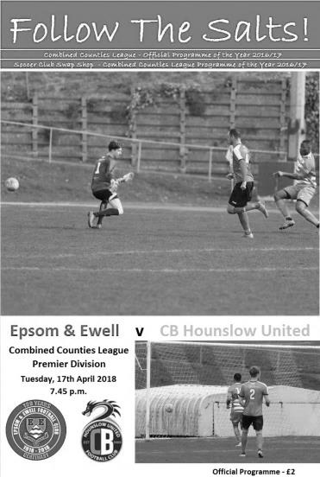
Salts turnaround stuns Dragons

For the second time in four days we had to retrieve a two goal deficit. However, this time we were able to get in front and finish the job, and although the visitors finished with nine men, it should be made clear that we were ahead and in control before they started to lose players.

In our line-up we made two changes with Shaun Masterson and Taryn Smith earning a starting place at the expense of Ben Dyson and Louis O'Brien. Ashley Thompson retained the armband despite Alex McKay's return to the team, as he had to be content with a place on the bench, although he would join the fray later.

On an evening where we marked 25 years to the day since our last League match at West Street, this was a strange match to witness. Not that many people actually witnessed it; with the attendance of 23 being less than the number of players who took part in the match! It was played at a high tempo throughout, although neither team were able to string too much together in the way of possession as a result. Having said that, CB Hounslow could have taken the lead with the clock showing thirty seconds when a poor clearance from Masterson went straight to their player whose shot at goal from the edge of the area flew away off Conor Young's left hand post and out for a goal kick.

We fashioned our first chance in the tenth minute following an excellent advantage from the referee. Reisse Griffin got down the right after originally being impeded and sent over a peach of a cross, but Joe Loftus-Cheek was unable to get a more solid contact with his head from twelve yards out and the ball went wide of the post.

The visitors held the balance of possession in the opening half hour as more of the match was played in our half, but apart from a dangerous corner that went straight through our six yard box and a couple of easy saves for Young we were not in any real trouble. This changed in the 30th minute when a left wing cross came in and their Captain Jordan Ireland had too much space to steer his low header just inside the post. Two minutes later another ball from the left was met by Ireland with a superb strike from fully twenty yards into the top corner that gave Young no chance.

It was a goal worthy of winning any match and it looked like that may well be the case, but our players clearly hadn't read the script and fought back. Loftus-Cheek chased a bouncing ball and just got in front of Gabriel Chiedozie who then brought him down. It was a penalty, although the subsequent yellow card was a little harsh. Either way Scott Murphy dispatched

the penalty and after 41 minutes we were back in the match. Less than sixty seconds later we were level and this time it was our turn to produce a good goal. Griffin delivered a deep ball to the far post where Smith was able to head it back across goal for Thompson who was able to sweep the ball in from six yards.

After this bizarre turnaround I'm not sure anyone knew what would happen in the second half but we certainly had the momentum and nearly went ahead in the 50th minute when a defensive error let Loftus-Cheek in. Although he was well held up by a defender, Griffin's shot was just deflected over the bar by a defender. It didn't matter though as Masterson's half cleared corner came back to him; his second delivery found Thompson at the back post and he sent it low into the danger area where Loftus-Cheek pounced first and drilled the ball into the bottom corner of the goal from about eight yards.

The visitors raised their game for a while as they pushed for an equaliser and a good battle was had by Endrit Dobraj who competed well against their left winger all night. They pressed for a few minutes and we blocked a dangerous shot but we gradually weathered the storm and countered well. Marlon Pinder produced a good run, but the shot was wide and we followed this with some more nice football that resulted in Griffin firing over the bar from twelve yards. By this time the visitors had used their one named substitute and although they tried to get back into the match, Young denied Shakeel Morris an equaliser with his right boot.

Griffin was a constant source of danger and it required a well-timed tackle to deny him in the box after Loftus-Cheek had forced the initial error and from another Masterson corner Thompson was unfortunate to see his powerful volley strike an unaware defender and deflect away for a corner. From the set piece Griffin was inches wide with a 20 yard volley and even Dobraj got in on the action as he was the beneficiary of a clever through ball from Pinder, although his shot was well stopped by Rhys Doherty in the Hounslow goal, who had cancelled birthday plans to come in at short notice for his club.

He'd have enjoyed his evening even less in the 78th minute when Pinder cut in from the left wing, beat two men and fired in a low shot from the edge of the area that crept under the keeper's right hand on its way into the net to give us a 4-2 lead. By this time the visitors had been reduced to ten men following an injury to Luke Bersey, and worse was to follow when Billy Roach was injured in the 88th minute. The game was up and we were understandably able to find a lot of space now. Passing the ball around in complete control was a strange feeling that we have not seen too often this season and when substitute Liam Roberts was bundled over from behind we had our second penalty of the evening which Adam Heagney tucked away; the ball hopping over the keeper's dive in the 93rd minute.

I'll be honest. I thought the game was up at 2-0 down, but full credit goes to the players for working hard and on this occasion at least, earning their reward. We closed the gap at the bottom on Farnham Town to two points, which is the smallest gap since 21st November. Maybe we can still get off the bottom yet!

Epsom and Ewell: Conor Young, Endrit Dobraj, Shaun Masterson, Lloyd Connelly, Adam Heagney, Ashley Thompson (c), Reisse Griffin, Scott Murphy, Joe Loftus-Cheek, Marlon Pinder, Taryn Smith

Subs: Ben Dyson for Smith for O'Brien (59), Alex McKay for Murphy (63),
Liam Roberts for Loftus-Cheek (79)

From behind the goal
North Greenford United 0-4 Epsom & Ewell
Combined Counties League - Premier Division - Thursday 19th April 2018

Away day joy for Salts who climb off the bottom

We may well be facing relegation to Step Six at the end of this wretched season, but from watching our performances in the last week you'd think we were a top half team as we followed up our 2-2 draw with Champions Westfield with five goals on Tuesday against CB Hounslow United and then scored another four at North Greenford; a venue where we hadn't won since September 2007 when James Earp scored a couple in a 3-2 in a League Cup win! It was also our first League win at Berkeley Fields in six attempts and was a great way to mark our 500th Combined Counties League match.

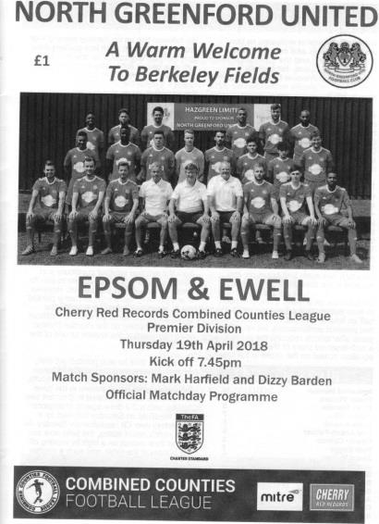
It must also be obvious that we have started to score goals too and our front two of Joe Loftus-Cheek and Kyen Nicholas, starting as a pair for the first time worried the life out of the opposition all evening and both got on the score sheet, although it was Louis O'Brien whose first two goals for the club broke their resistance and ultimately set up our win, during a first half where we completely outplayed, out battled and completely dominated our hosts.

Alex McKay came back into the starting line-up for the absent Endrit Dobraj with Adam Heagney moving to right back, while up front Nicholas and O'Brien came back in ahead of Taryn Smith and the absent Marlon Pinder. In the opening minutes the hosts had a couple of long range efforts that Conor Young dealt with comfortably, but we would get on top and stay there from that point until half time. A Heagney free kick caused panic in the area and earned us a corner and a few minutes later Nicholas and Reisse Griffin combined well on the right to earn us another. The Shaun Masterson delivery was met by the head of Scott Murphy who saw the ball diverted off the line by a defender onto a team mate, rebounding kindly for the keeper Bailey Mulhall to gratefully dive on the loose ball inches from the goal line.

Another Masterson corner was met at the near post by a combination of striker and defender with the ball being headed off the line by Michael Adjei. Just after the twenty minute mark Loftus-Cheek got through on the right, but as he cut inside he took a heavy touch and the ball was cleared. Undeterred, three minutes later he headed a corner from the other side of the pitch against the underside of the Greenford crossbar, but the danger was cleared.

We still had to be alert though and from a rare right wing attack, Lloyd Connelly was just able to get a head to the cross to divert the ball away from their striker waiting behind him in space. However, we were soon attacking down the hill again and from a free kick on the right, Masterson's set piece was met by O'Brien who was just wide with a header.

The home goal had been leading a charmed life to this point, but the pressure finally told in the 39th minute and the floodgates well and truly burst open in the remaining minutes of the half. It

was ironic that after playing such nice football to this point, our first goal came pretty much from a direct and harmless looking punt up the field. Mulhall called for the defender to leave it, but maybe hadn't seen O'Brien who reached the ball first and threaded it under the advancing keeper and into the net from twenty yards for the opener.

Two minutes later we attacked on the left and with the defenders concerning themselves with our front two the ball went over to the right hand side of the area where O'Brien hit a powerful shot. Mulhall got a good hand on it to divert the ball up, but it had too much momentum and it fell to the ground and bounced up into the net for our second goal before a defender could clear it.

The attacks continued and a fine ball over the top put Loftus-Cheek through and he lofted his shot above Mulhall and into the net in the 44th minute and within 40 seconds Nicholas had finished from a similar distance right into the top corner, giving Mulhall no chance. It was an inspired six minutes and you have to go back a long way to find four goals in such a short period of time, and yes, I've already looked at our 9-2 win at Bedfont & Feltham from 2016!

The goals were thoroughly deserved and we had been unfortunate not to be ahead earlier. However, the second half would prove to be a much closer affair as the home side attacked the bottom goal and Young had to be alert to make a save from a header at the near post from a corner in the 54th minute and from a decent strike at goal a couple of minutes later. Our intensity remained high throughout and we closed the opposition down frequently, so there was no taking the foot off the pedal and we had further chances of our own. O'Brien went down in the area as he rounded his opponent but it was the sort of decision you would only ever get in the middle of the park as Adjei did get some of the ball, if a little clumsily.

Then in the 69th minute Loftus-Cheek was on the attack, and although he was held up by the defender, they hadn't seen our substitute Ben Dyson sneak up on his blind side and he pinched the ball and ran with it at goal, cutting back and shooting at goal. Mulhall made a good save and the danger was cleared, but with Griffin and another substitute Liam Roberts waiting you wondered whether he might have had a better option.

The home side got closer to our goal and drilled one shot a couple of feet to the side of Young's right hand post, while in response Loftus-Cheek was felled in the area as he ran onto a Rory Sellick pass, but again I think the referee got it right as he also did with his use of the advantage law which was consistent and sensible and an example to many others.

We had a let off on two occasions just at the end of the match, firstly when Sammy Adams broke through on goal but went for power and sent his shot over the bar and out of the ground, while a minute later James Bennett actually took the ball around Young but went a little wide and slipped as he tried to retrieve the ball for what looked like a tap in from where I was, but somehow Young recovered and was able to keep the ball out.

As the whistle blew for full time the cold hard facts will show that all the damage was done in a six minute spell, but this was an impressive performance throughout, particularly in the first half and brought the added bonus of climbing us above Farnham Town after having spent over eight months at the foot of the table. The players now have a well-deserved Saturday off before making the journey to Walton & Hersham on Tuesday.

Epsom and Ewell: Conor Young, Adam Heagney, Shaun Masterson, Lloyd Connelly,
Alex McKay, Ashley Thompson (c), Reisse Griffin, Scott Murphy, Joe Loftus-Cheek,
Kyen Nicholas, Louis O'Brien

Subs: Rory Sellick for Thompson (57), Liam Roberts for Nicholas (62), Ben Dyson for O'Brien (69)

From behind the goal
Walton & Hersham 4-0 Epsom & Ewell
Combined Counties League - Premier Division - Tuesday 24th April 2018

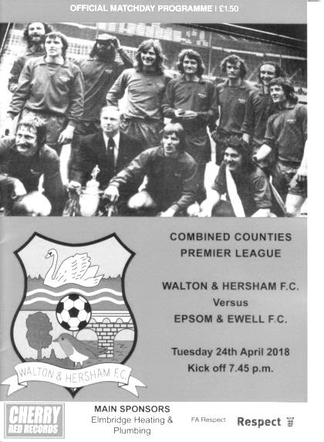
Not so fantastic on plastic!

Last week as the sun shone, the Salts made hay with seven points from a possible nine. Fast forward to a miserable Tuesday evening on the Astroturf at the Elmbridge Sports Hub and things didn't go as well, being comfortably beaten on the night by a very good Walton & Hersham side. Overall this season that means we have played four matches on artificial surfaces, but have failed to score in any of them, conceding sixteen!

Of course, it must be said that those matches have been against some of the best teams in our League and the Swans showed why they deserved to be right up there themselves as they covered every inch of ground and restricted our boys to mostly half chances, while on another night they might have got close to the nine they put past Banstead Athletic earlier on the season if they had finished more of their chances.

There was one bright spot which was the 200th appearance by our Captain Alex McKay, becoming only the 36th player in 100 years to achieve the feat and the first since 2014, and although he probably won't remember the evening with much fondness it is still a significant achievement.

We made just one change from our win at North Greenford United with Marlon Pinder coming in for the absent Ashley Thompson and started with a similar formation, putting our two big men Joe Loftus-Cheek and Kyen Nicholas up front again, but they were kept fairly quiet throughout the match and their service was limited too.

The home side signalled their intent to attack us on the flanks with a superb diagonal ball as early as the second minute which went over Shaun Masterson and was taken in stride by Tinashe Nkoma. He ran straight in on goal where Conor Young had to make an early save for a corner that was cleared. In response a long throw from McKay was actually flicked on by a Walton defender but there was no one at the far post to meet the ball.

The home side were back on the attack in the 11th minute when a good Nkoma delivery was met by a glancing header at goal from Sam Shaban, although Young was fortunate to see the ball hit his right hand post and bounce straight back to him! Unfortunately they earned a corner a minute after this and it wasn't cleared with Jake Newton stooping to head the ball into the net to open the scoring.

Scott Murphy had a shot from distance but it was wide of goal and it was a little disappointing that we didn't have a few more tries with the wind behind us. Our next attack

was a free kick sent to the far post by Adam Heagney and it was met by a Lloyd Connelly header that was wide, although the flag was up and it wouldn't have counted.

Louis O'Brien then had a half chance at the far post after an earlier shot was blocked but was unable to keep the ball on target with his low drive. We then lost the ball and Abdeen Abdul broke clean through, but Young made a good save from fairly close range. The same player would also be just wide with a low effort a few minutes later and he also put in a dangerous low delivery that Reisse Griffin just managed to divert the other side of our post for a corner.

With seven minutes remaining in the half we had our best move of the match when O'Brien cleverly lifted the ball over the back four for Loftus-Cheek who got to the touchline and sent in a low ball beyond Brendan Norris, but Nicholas was inches away from the ball and couldn't quite reach it. Within seconds we paid for the missed opportunity when Connelly was robbed by Bruno Tingle who strode through and buried the ball past Young from close range.

As the half closed Nicholas had an opportunity but his shot was not strong enough to beat Norris who made the save low down to his right. It would be the last time we'd see the goal for a while as the second half started with the home side rampant. Their left winger skipped in between two players with the ball and laid the ball on a plate for the incoming striker but Young made a good save of a slightly scuffed shot to keep the ball out. From the subsequent corner the ball was headed narrowly over. Then Nkoma struck his shot over from a good position before Abdul chipped Young but was off target. Finally, they scored a third goal in the 56th minute as Nkoma skipped past Masterson on the right and delivered a textbook low cross to the far post where Shaban couldn't miss from close range.

We made a triple substitution with Ben Dyson, Liam Roberts and Endrit Dobraj introduced but the home side kept pushing and somehow failed to finish off another right wing delivery that appeared almost perfect but somehow the close range header hit Young's left hand post and stayed out. Less than a minute later a similar deep cross from the right was volleyed wide from a good position and as you began to count up the missed chances, you realised that we were maybe fortunate to only be three down at this point.

After 69 minutes Dobraj tried his luck from the edge of the area with a curling strike that wasn't far away from the far post and then five minutes later Dyson made a great run down the left and got inside the six yard box, but was unable to get the ball to a team mate with his weaker foot and it was cleared just ahead of the approaching Nicholas.

In the final quarter of an hour we saw a little more of the ball and Nicholas controlled a left wing cross on his chest but had the volley well blocked and Elliott Simpson made the score line look more accurate with a low drive from 20 yards that caught Young out a minute from the end of normal time. It nearly became five-nil after another right wing cross skipped through our six yard box and out the other side.

In summary, there was no disgrace in losing to a side registering their fifth straight win, but this result provided a telling reminder that we are still some distance from the better sides in this division when they are fresh and still have something to play for.

Epsom and Ewell: Conor Young, Reisse Griffin, Shaun Masterson, Lloyd Connelly, Alex McKay (c), Adam Heagney, Marlon Pinder, Scott Murphy, Joe Loftus-Cheek, Kyen Nicholas, Louis O'Brien

Subs: Liam Roberts for Connelly (59), Ben Dyson for O'Brien (59),
Endrit Dobraj for Masterson (59)

This Day in History - Club Records - 28th April
Date | Day | Competition |  | Opponents |  | Scorers
28/04/28 | Sat | London League | H | Grays Athletic | 0-1
28/04/32 | Thur | London League | A | Finchley | 0-0
28/04/34 | Sat | London League | A | Chelmsford | 3-3 | L.Marlow (2), W.Challis
28/04/37 | Wed | London League | H | Leavesden | 1-1 | A.Griffiths
28/04/51 | Sat | Friendly | H | Guildford | 3-1 | T.Wright (2), F.Boatwright
28/04/54 | Wed | Corinthian League | A | Hounslow Town | 2-4 | G.Hurst, B.Wiles
28/04/60 | Thur | Corinthian League | H | Worthing | 5-1 | B.Hawkins (2), J.Sorensen, T.Millard, P.Wood
28/04/75 | Mon | Surrey Senior League Charity Cup SF | A | Merstham | 3-1 | D.Ritman (2), T.Tuite
28/04/77 | Thur | Athenian League 1 | H | Alton Town | 0-1
28/04/79 | Sat | Isthmian League 1 | A | Bishop's Stortford | 1-2 | D.Walker
28/04/80 | Mon | Southern Combination Cup Final | A | Hampton | 7-2 | T.Tuite (5), R.Beswick (2, 1 pen)
28/04/81 | Tue | Isthmian League 1 | H | Clapton | 4-0 | T.Tuite (3), J.Hunn (pen)
28/04/83 | Thur | Southern Comb. Cup SF | H | Chalfont St Peter | 1-0 | S.Hill
28/04/84 | Sat | Isthmian League 1 | H | Clapton | 2-1 | A.Morton (2 pens)
28/04/87 | Tue | Isthmian League 1 | A | Basildon United | 3-0 | J.Richardson (2, 1 pen), T.Tuite
28/04/90 | Sat | Isthmian League 2s | A | Harefield United | 3-2 | C.Hadingham (2), S.Alldridge
28/04/99 | Wed | Isthmian League 3 | H | Wingate & Finchley | 0-2
28/04/01 | Sat | Isthmian League 3 | H | Kingsbury Town | 2-2 | B.Stevens, A.Nimmo (pen)
28/04/07 | Sat | Combined Counties Premier Division | H | Colliers Wood United | 0-2
28/04/09 | Tue | Combined Counties Premier Division | A | Camberley Town | 2-3 | R.Burns, A.Amfo-Brobbey
28/04/11 | Thur | Combined Counties Premier Division | A | Mole Valley SCR | 1-4 | R.White
Historical Decades
90 years ago – Epsom Town F.C.
28/04/28 | Sat | London League | H | Grays Athletic | 0-1
80 years ago – Epsom F.C.
27/04/38 | Wed | London League | A | Tilbury | 2-4 | J.Jones, B.Randall
70 years ago – Epsom F.C.
24/04/48 | Sat | London League | A | P.O.Telecoms | 2-0 | L.Gilbert (2)
60 years ago – Epsom F.C.
29/04/58 | Tue | Wells Cup 2nd leg | A | Leatherhead | 2-3 | K.Harris, B.Smith
50 years ago – Epsom & Ewell F.C.
27/04/68 | Sat | Athenian League Div 2 Cup Final 1st leg | A | Edmonton | 0-3
40 years ago – Epsom & Ewell F.C.
25/04/78 | Tue | Isthmian League 2 | A | Egham Town | 3-1 | T.Tuite (2), T.McCready
30 years ago – Epsom & Ewell F.C.
27/04/88 | Wed | Isthmian League 2s | A | Horsham | 1-1 | B.Perkins
20 years ago – Epsom & Ewell F.C.
27/04/98 | Mon | Isthmian League 3 | H | Harlow Town | 2-3 | A.Boxall, P.Bunter
10 years ago – Epsom & Ewell F.C.
26/04/08 | Sat | Combined Counties Premier Division | A | Sandhurst Town | 2-3 | R.Burns, J.Ellis

History Corner – 28th April
90 years ago today we would be able to clinch the London League title if only we could defeat our main challengers Grays Athletic at West Street. We had lost our first home match of the season against Carshalton Athletic the previous Saturday and this too was a nervy performance which we also lost 1-0. This meant we would need two wins for the title, one at home to Millwall United in midweek but far more dauntingly at Grays seven days after this match.

We would defeat Millwall comfortably enough but trailed at Grays and then missed a penalty before turning the game around with two goals from Fred Watts to win the match 2-1. We were London League Champions and would be runners-up on five more occasions during the thirties, although would never win it again.

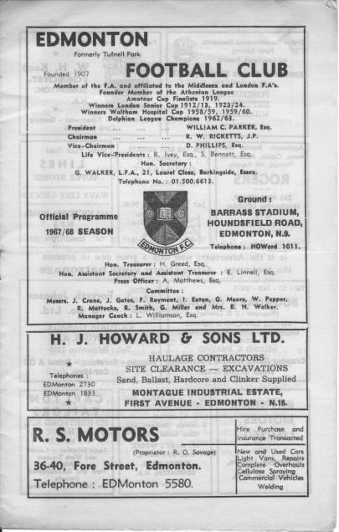
50 years ago this week we visited Edmonton in the Final of the Athenian League Division Two Cup, which was a two legged affair. We visited the Barrass Stadium but were thoroughly outplayed by three clear goals. (see programme left) Worse was to follow two weeks later as we lost the second leg at West Street 4-0 to lose the Final 7-0 on aggregate in what was Chris Kelly’s final match for the club. Yes, Chris Kelly started his senior career here, not at Leatherhead, Tooting & Mitcham or Millwall as many think.

40 years ago this week there were happier memories as we visited Egham Town, largely to celebrate our League title that had been won a few days previously and defeated the hosts 3-1 with two from Tommy Tuite and the other from Tommy McCready. (see article in programme)

38 years ago today we won the Southern Combination Cup for the only time in our history against Hampton at their own ground, and by seven goals to two! (see programme below) Tommy Tuite scored five goals that day to equal his own club record for goals scored in an away match that he had set at Ruislip Manor in November 1976 and that he would match again in April 1985 at Windsor & Eton. Roy Beswick scored the other two, one from the penalty spot as we made light work of a team Managed by Ted Murphy, our former player who had also played in the F.A. Cup Third Round for Tooting & Mitcham in 1959 against eventual winners Nottingham Forest, scoring at both ends in a famous 2-2 draw! He was also an Amateur Cup winner with Wimbledon in 1963.
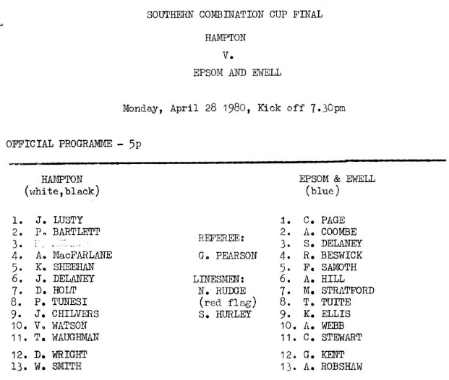

Ryman League Division One South Table
incl Tuesday 24th April | P | W | D | L | F | A | Pts | GD
Carshalton Athletic (P) | 45 | 30 | 9 | 6 | 92 | 54 | 99 | +38
Lewes (P) | 45 | 30 | 8 | 7 | 93 | 38 | 98 | +55
Greenwich Borough | 45 | 25 | 12 | 8 | 99 | 46 | 87 | +53
Cray Wanderers | 45 | 24 | 14 | 7 | 108 | 46 | 86 | +62
Corinthian-Casuals | 45 | 26 | 8 | 11 | 85 | 46 | 86 | +39
Hythe Town | 45 | 25 | 10 | 10 | 91 | 62 | 85 | +29
Walton Casuals | 45 | 24 | 11 | 10 | 94 | 51 | 83 | +43
Hastings United | 45 | 20 | 13 | 12 | 83 | 65 | 73 | +18
Thamesmead Town | 45 | 19 | 12 | 14 | 97 | 79 | 69 | +18
Whyteleafe | 44 | 18 | 13 | 13 | 78 | 67 | 67 | +11
Phoenix Sports | 45 | 19 | 9 | 17 | 75 | 68 | 66 | +7
Herne Bay | 45 | 20 | 5 | 20 | 80 | 89 | 65 | -9
South Park | 44 | 19 | 6 | 19 | 76 | 82 | 63 | -6
Sittingbourne | 45 | 17 | 8 | 20 | 66 | 71 | 59 | -5
Horsham | 45 | 16 | 8 | 21 | 69 | 85 | 56 | -16
VCD Athletic | 45 | 15 | 7 | 23 | 69 | 84 | 52 | -15
Ramsgate | 45 | 14 | 9 | 22 | 75 | 85 | 51 | -10
Guernsey | 45 | 13 | 10 | 22 | 65 | 94 | 49 | -29
Faversham Town | 45 | 13 | 9 | 23 | 60 | 71 | 48 | -11
Chipstead | 45 | 12 | 9 | 24 | 64 | 78 | 45 | -14
East Grinstead Town | 45 | 9 | 9 | 27 | 63 | 124 | 36 | -61
Ashford United | 44 | 9 | 8 | 27 | 56 | 106 | 35 | -50
Molesey (-3) | 43 | 5 | 12 | 26 | 49 | 98 | 24 | -49
Shoreham (-6) (R) | 44 | 3 | 5 | 36 | 32 | 130 | 8 | -98
After Lewes had held the pole position for much of the season and appeared to see off the challenge from Cray Wanderers, Carshalton Athletic have nipped ahead of both and require a win today home to VCD Athletic to clinch the title. Lewes inexplicably slipped up 2-0 at Faversham Town on Saturday to open the door. It’s not that serious though, as three go up and both had clinched the two automatic spots a while ago.

In the playoffs, It’s four from five with Corinthian Casuals defeating Guernsey 5-0 on Tuesday to jump back in. Walton Casuals are just outside Greenwich Borough, Cray Wanderers and Hythe Town in the post-season battle. However, Corinthian Casuals’ final match is at Hythe Town so Walton will be guaranteed in with a win at Ashford United today.

After seeing Chipstead do fairly well earlier in the season it is a surprise to see them back down in the danger area, and whilst only one club go down, and Shoreham have held that position for a while, the emergence of Molesey and Chipstead as strugglers is a concern for next season as both are in our Step five catchment area and it is quite possible that one less club could come back up from the Combined Counties Division One, should two clubs drop down from Step Four into the Premier Division.

Last season I predicted that this would be Guernsey’s final season before trying to “do a Gibraltar” but we’ll never know whether that was their plan as during the season Jersey tried exactly that application and had it rejected, so for Guernsey, that door appears closed too.

Combined Counties League Division One Table
incl Saturday 21st April | P | W | D | L | F | A | Pts | GD
Worcester Park (C) | 32 | 27 | 3 | 2 | 129 | 42 | 84 | +87
Badshot Lea | 34 | 24 | 4 | 6 | 118 | 62 | 76 | +56
Cobham | 33 | 21 | 7 | 5 | 96 | 41 | 70 | +55
Sheerwater | 33 | 20 | 8 | 5 | 94 | 54 | 68 | +40
Frimley Green | 35 | 19 | 7 | 9 | 92 | 53 | 64 | +39
Staines Lammas | 32 | 19 | 5 | 8 | 77 | 54 | 62 | +23
Raynes Park Vale | 30 | 18 | 3 | 9 | 79 | 47 | 57 | +32
AC London | 33 | 19 | 0 | 14 | 72 | 55 | 57 | +17
Eversley & California | 34 | 16 | 4 | 14 | 89 | 80 | 49 | +9
Ash United | 33 | 13 | 5 | 15 | 58 | 77 | 44 | -19
FC Deportivo Galicia | 33 | 10 | 5 | 18 | 60 | 78 | 35 | -18
Farleigh Rovers | 27 | 10 | 5 | 12 | 55 | 65 | 34 | -10
Chessington & Hook Utd | 30 | 10 | 4 | 16 | 71 | 85 | 34 | -14
Kensington Borough | 32 | 9 | 3 | 20 | 50 | 81 | 30 | -31
Bedfont & Feltham | 35 | 7 | 4 | 24 | 51 | 94 | 25 | -43
South Park Reserves | 27 | 6 | 6 | 15 | 40 | 77 | 24 | -37
Fleet Spurs | 34 | 6 | 4 | 24 | 55 | 101 | 22 | -46
Cove | 33 | 6 | 3 | 24 | 39 | 93 | 21 | -54
Bagshot | 32 | 5 | 2 | 25 | 39 | 125 | 17 | -86
It’s been a bittersweet season for Worcester Park. Leaving aside their quest for League Cup glory against Knaphill in a couple of weeks, they are Champions of the Division but unlike in previous years where they have been denied promotion, this time they are to be relegated.

It would be very easy to moan about this decision as some uninformed people have been doing on Twitter recently, and blame the League (who have nothing to do with the decision) or the F.A. for their reorganisation and bemoan the fact that poor little Worcester Park are being denied their chance at success, but hold on a minute, let’s consider ALL of the facts here.

Firstly, Worcester Park, along with Staines Lammas and Farleigh Rovers have been threatened with relegation for some time. They have had two reprieves previously. Also, Worcester Park have refused to upgrade the ground to the required standard, while several other Step Six clubs have spent large sums of money on theirs to avoid their own threat of demotion. Why bother if the F.A. were to backtrack once again and not relegate a club that have ignored them for a decade?

Finally, regardless of whether they only have crowds of a certain size, their facilities, clubhouse aside, are really poor now for the standard they are at. Not only are they missing lights but you can only stand on one side of the ground. The game has moved on into the twenty-first century and if my club had spent thousands of pounds getting their ground up to the required standard or paying to ground share, I’d be thinking about legal action if another club down the road could just get away with it by ignoring the ruling. There are always two sides to every story.

So, Badshot Lea and Cobham are looking odds on to come up, but I am now hearing that anyone from the top six can be promoted if others fail their grading. I was under the impression that this was only the case if a Reserve team took a top three spot, but this news is especially bad news for Godalming Town who look like they are now very likely to join us and Farnham Town, while the favourites to be “promoted” in their place now appear to be Raynes Park Vale. I profoundly disagree that a sixth placed club can gain promotion ahead of a club in the flight above and it will be interesting to see how this turns out.

Alex McKay – 200 Appearances
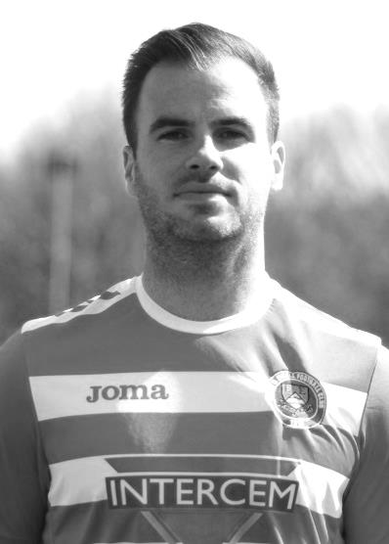
Congratulations go to our Club Captain Alex McKay who made his 200th appearance for our club on Tuesday 24th April at Walton & Hersham.

Alex is the first player to reach 200 appearances for our club since Alex McGregor on 29th March 2014 and becomes the 36th player in club history to reach that mark, which will earn him a place on the club Wall of Fame on our website when it is updated shortly.

Alex was born on 25th October 1986, which was a Saturday and that day we lost to a late goal at Broadhall Way, Stevenage Borough in the Isthmian League. They’ve moved up a bit since then!

He made his debut for the club on 20th December 2008 in a big League match at home to eventual Champions Bedfont Green which we narrowly lost 2-1 at Merland Rise.

Alex has a tendency to score some very important goals for us, and the one that springs to mind straight away was an injury time winner at home to Windsor on 1st April 2014, just seconds after the visitors had equalised and looked set to take a point from the match. It was Alex’s second goal of the match and he thumped a header into the roof of the net to clinch the points that evening. That picture is shown elsewhere in the programme.

Alex also scored twice at home to Westfield in the August of 2013, but his first goal came back on 25th April 2009 in a 3-0 home win over Wembley. He currently sits on exactly 200 appearances and 13 goals for the club.

A few years ago Alex filled out a Player Profile form and I thought you might like to see it. I’ve updated the ages and appearances.

Age: 31

Position: Centre-Back

Club supported: Arsenal

Favourite Meal: Fillet Steak and Chips with Peppercorn Sauce

Favourite Film: Back to The Future trilogy

Messi or Ronaldo: Thierry Henry!

Favourite Drink: Lemon San Pellegrino or Havana Club & Coke

Favourite Ground played at: Stamford Bridge

Best moment for Epsom:
- Winning the Combined Counties League Cup in 2013
- Scoring the last minute winner against Windsor in 2014

Describe the Gaffa (Glyn Mandeville) in three words: The - Train - Driver

Alex’s Playing Stats: First Team Debut : 20/12/2008

Appearances: 161 - Sub: 39 - Total: 200 - Goals: 13

EL Records Premier Challenge Cup
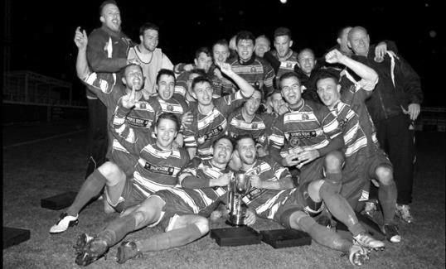
Second Round
CB Hounslow United | 1-2+ | Worcester Park
Chertsey Town | 1-0 | Horley Town
Colliers Wood United | 4-1 | Balham
AFC Hayes | 0-1 | Cobham
Knaphill | 3-1 | Guildford City
Cove | 0-1 | Sutton Common Rovers
Bagshot | 1-4 | North Greenford United
Bedfont Sports | 6-1 | Farleigh Rovers
Redhill | 9-0 | Fleet Spurs
Kensington Borough | 4-3 | Raynes Park Vale
Bedfont & Feltham | 0-1 | Godalming Town
Chessington & Hook United | 5-2 | Sheerwater
Spelthorne Sports | 5-1 | Ash United
Walton & Hersham | 6-1 | Badshot Lea
Abbey Rangers | 1-3 | FC Deportivo Galicia
Banstead athletic | 0-3 | Farnham Town
Third Round
Cobham | 5-0 | Farnham Town
North Greenford United | 0-4 | Colliers Wood United
Sutton Common Rovers | 5-0 | Redhill
Godalming Town | 3-2 | Chessington & Hook United
Knaphill | 2-0 | Kensington Borough
Bedfont Sports | 0-1 | Walton & Hersham
Spelthorne Sports | 1-0 | Chertsey Town
Worcester Park | 6-1 | FC Deportivo Galicia
Quarter-Finals
Godalming Town | 0-2 | Knaphill
Spelthorne Sports | 1-3 | Walton & Hersham
Sutton Common Rovers | 2-1 | Cobham
Worcester Park | 5-2 | Colliers Wood United
Semi-Finals
Worcester Park | 3-2 | Sutton Common Rovers
Walton & Hersham | 1-2 | Knaphill

Surrey Senior Cup
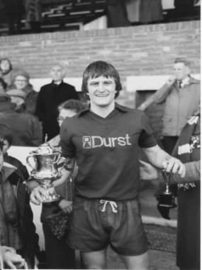
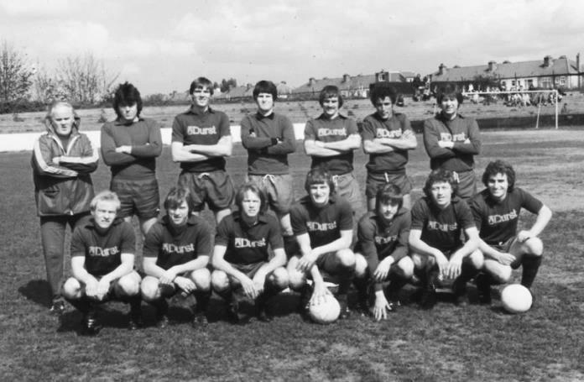

First Round
Westfield | 2-2 – (4-2p) | Camberley Town
Woking | 1-3 | Chipstead
Chertsey Town | 1-2 | Spelthorne Sports
Dorking Wanderers | 4-1 | Godalming Town
Horley Town | 0-2 | Kingstonian
AFC Croydon Athletic | 1-5 | Met Police
Tooting & Mitcham United | 1-0 | Corinthian Casuals
Carshalton Athletic | 6-2 | Egham Town
Croydon | 2-2 (11-12p) | Molesey
Farnham Town | 2-2 (5-4p) | Whyteleafe
Sutton United | 2-1 | Redhill
Banstead Athletic | 2-5 | Leatherhead
Sutton Common Rovers | 0-0 (4-5p) | Epsom & Ewell
Guildford City | 2-2 (3-5p) | Colliers Wood United
Merstham | 3-0 | Walton & Hersham
South Park | 2-2 (4-2p) | Ashford Town (Mx)
Second Round
Leatherhead | 2-0 | Kingstonian
Epsom & Ewell | 0-5 | Merstham
Farnham Town | 0-3 | Met Police
Westfield | 2-3 | Colliers Wood United
Spelthorne Sports | 0-4 | South Park
Sutton United | 7-1 | Molesey
Chipstead | 3-2 | Tooting & Mitcham United
Dorking Wanderers | 2-1 | Carshalton Athletic
Quarter-Finals
Met Police | 1-1 - (2-4p) | Leatherhead
Colliers Wood United | 0-6 | Dorking Wanderers
Sutton United | 1-2 | Merstham
Chipstead | 0-1 | South Park
Semi-Finals
Dorking Wanderers | 0-1 | Leatherhead
Merstham | 6-0 | South Park

Buildbase F.A. Vase
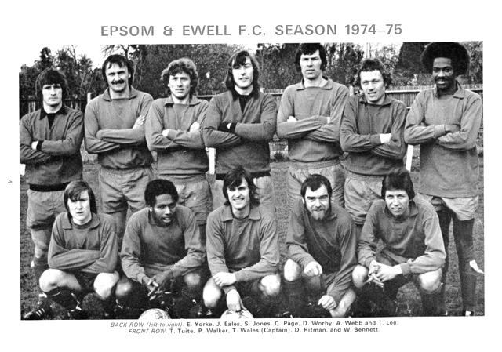

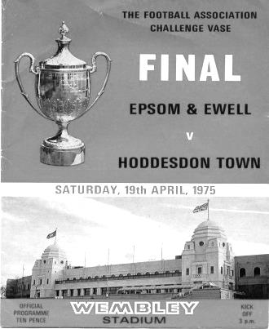
Fourth Round
Newcastle Benfield | 1-1+r 1-1+ (2-4p) | Coleshill Town
Wisbech Town | 1-3 | Bromsgrove Sporting
Cogenhoe Town | 2-3 | Wolverhampton SC
Marske United | 5-0 | Hinckley AFC
Stockton Town | 2-1+ | West Auckland Town
1874 Northwich | 3-1 | Pontefract Collieries
Desborough Town | 2-4+ | Stourport Swifts
Melksham Town | 2-1 | Crowborough Athletic
Westfields | 1-4 | Hamble Club
Blackfield & Langley | 3-3+r 1-2 | Bracknell Town
Leighton Town | 5-2+ | Norwich CBS
Newport (IOW) | 0-1 | Bradford Town
Eastbourne Town | 1-3 | Windsor
Horley Town | 1-2 | Chichester City
Tring Athletic | 5-1 | Hullbridge Sports
Thatcham Town | 2-1 | Biggleswade
Fifth Round – 3rd February
Wolverhampton SC | 3-4 | Leighton Town
Thatcham Town | 2-1 | Bromsgrove Sporting
Marske United | 2-0 | Bradford Town
Coleshill Town | 2-4+ | Bracknell Town
1874 Northwich | 1-0 | Chichester City
Stockton Town | 3-0 | Stourport Swifts
Windsor | 2-0 | Hamble Club
Melksham Town | 2-1 | Tring Athletic
Quarter-Finals – 24th February
Bracknell Town | 0-3 | Marske United
Melksham Town | 0-1 | Thatcham Town
Stockton Town | 2-0 | Windsor
Leighton Town | 0-1 | 1874 Northwich
Semi-Finals – 17th March & 24th March – two legs
Stockton Town | 2-0 – 1-2 | Marske United
Thatcham Town | 1-0 – 3-2 | 1874 Northwich

Club Treasurer - Steve Dyke
I’m sure Richard might already have mentioned the historical context that every time we have a major player walk out a poor season and relegation has usually followed.

It’s true that the season ultimately has been defined by the loss, mostly to the same place, of most of last season’s team and we were not able to recover from it in time (just). However, following our storming last week hopefully followed up this week we can look forward to next season with optimism hoping we will have as short a sojourn as possible in Step Six.

The early weeks of the season were difficult with a lot of goals conceded. Glyn had placed a lot of faith in players from the recent past coming back in our hour of need. Sadly, a number were unable to recapture past glories and we may have said goodbye to some in a way neither they nor us at the club would want.

Being involved in the running of the club gives you a slightly different perspective than when you are solely a supporter as you know what people are trying to do even if it doesn’t work out. The lack of points and massive hit to goal difference from the early part of the season has hampered us all year.

Then we went to Rusthall! One of the most frustrating things about this season is the thought that there is potential within the squad which until recently has only sporadically appeared, but for a team’s first win to be 7-2 including perhaps the best individual goal I have ever seen was bizarre.

Rusthall marked the first appearance at our club of Neil Grant as coach. In trying to deal with the poor start the Committee took the option of getting more coaching expertise in and additional training to improve matters.

The middle part of the season was perhaps the most frustrating. Less goals were being conceded and the squad was becoming younger and slowly more stable. At the time I frequently offered the opinion that if we were involved in tighter more competitive games then some of them would fall our way.

Somehow we managed to find ways of losing even the tight competitive games with chances missed and goals conceded against the run of play, the matches against Chertsey and AFC Hayes away being particularly pivotal. So luck was against us at times as well.

Glyn decided to leave and hand the reins onto Neil and it was fitting his final game with us was a win at Godalming. Glyn was a good Manager for us and for over three years was a pleasure to work with. He worked well in tandem with Neil for a spell and Neil has taken on the role with considerable enthusiasm and personally I am pleased we are now beginning to see the fruits of his work in results.

As we mark the end of an ultimately unsuccessful season there are things we can look back on with fondness. A number of the players have battled through a difficult season, often playing in several different positions and shown great commitment to the cause improving as the season had gone on. The team spirit and cohesiveness of the group is now really good and I hope this will continue into a successful season next year.

Personally one of the highlights of the year for me has been it has been the first season as a supporter for my son Sam. There have been times when I have really regretted that his first season as a supporter could not have been more successful, but his enthusiasm has been infectious and he has learned a lot about the jobs needed to keep the club running on matchday. He also completes a league table with Uncle Geoff every Sunday, a job my dad used to do and it was lovely on Sunday to finally not be in bottom place!

As Neil has said there is a lot to look forward to. Keep coming to games, bring friends and continue to support the club with super Six tickets and sponsorship. Off the field we have made progress and we have the most positive relationship with the Council in our many years of exile.

Although we may be going down now, this could be a turning point for us on and off the field.

Come on You Salts!

Steve

40 Years ago
The season of 1977/78 was the last time we would win a League division Title as Champions of the fledgling Isthmian League Division Two.

Pat O’Connell had been a massive success for our club since his appointment in 1973. Whilst people will remember the F.A. Vase Final we also secured two League Cup wins and a Surrey Senior League win in the first two years, followed by a promotion as Runners-Up in the Athenian League Division Two and an Athenian League Cup Final in 1976/77, being narrowly defeated by Chalfont St Peter.

Now we were accepted into the newly created Second Division of the Isthmian League, arguably the premier competition in the South East. It was quite a small division really with only 17 clubs in the constitution. Some would go on to play at a high level like Farnborough Town, (and now Farnborough FC) Lewes and Hemel Hempstead Town, while others would not exist for much longer, with Willesden, Epping Town, Letchworth Garden City and Rainham Town all failing to see the Century out. There were clubs who have gone on to play at a slightly higher level, like Worthing, Met Police, Molesey, Cheshunt and Egham Town, while others have just kicked around at this level for much of their existence like our old friends Camberley Town and Eastbourne United. The Division was completed by Tring Town and Feltham, now effectively replaced by Tring Athletic and Bedfont and Feltham.

But this was to be our year. We had an excellent team, but the previous season we had switched off a bit once we knew our application to the Isthmian League had been accepted and we finished mid-table. O’Connell knew he needed to strengthen the squad and five players made their debut as we opened up with a 2-1 win over Feltham at their old ground at the Arena, and although Bobby Page would only make ten appearances, the other four would have a great deal of success with all making at least forty-two appearances that season, and it should be remembered that we only played forty-five matches. Ian “Sos” Ferrar joined the club as a defender, as did former Wimbledon player Tommy McCready. Up front, young striker Richard Parkin would score 15 goals for us while versatile player and of course, future Chairman, Steve Delaney also made his debut that day, going on to make 326 appearances for the club; 10th overall in club history.

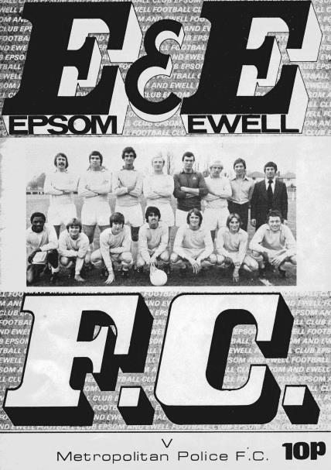
Our opening home match three days later was significant as it was the first ever home match played under floodlights at West Street. It was Tuesday 24th August 1977 and a goal from Parkin was the only one in the match against a team who would eventually come up with us as runners-up.

Of course we also had Tommy Tuite in our ranks still and he would net 32 this season; a little low by his standards but it must be remembered that this was a higher level of football for him too!

We followed our opening two League wins with a draw and another win, although Feltham defeated us in an F.A. Cup replay before Beckenham Town removed us from the London Senior Cup. We then lost our first league match as Molesey defeated us 3-2 at Walton Road and Delaney missed a penalty, but we earned progress in the F.A. Vase with wins over Ford United (now Redbridge), East Ham United and Ringmer. Hampton and Tooting & Mitcham ended our interest in the League and County Cups respectively and we also

found ourselves out of the F.A. Vase in January, despite three wins in the previous rounds without conceding as we were defeated 3-0 at West Street by Eastbourne United; a team we would defeat both home and away in the League.

This was a massive shock as was the home 0-3 defeat in the League that followed it against Tring Town, but we secured a point at Met Police from a 1-1 draw and would go on to remain unbeaten in our next 14 matches, winning eleven of them. Tuite scored hat tricks at Letchworth Garden City and at home to Epping Town, Eastbourne United and Cheshunt to carry us to the brink of the title.

O’Connell was quoted as saying that if we were to beat Lewes and Camberley in April then they would win the title. Both matches were won 1-0 and he would eventually be proved right. All we needed to do was to defeat Cheshunt on their own ground to win the title on Tuesday 18th April 1978. However, it didn’t go to plan and despite a goal from Gerry Archer we lost 2-1!

It didn’t matter though and before our final match of the season at Egham Town seven days later we had firstly received the news that we had been promoted when Farnborough Town had lost at Letchworth on the Saturday, and then on the Monday nearest rivals Met Police lost at Lewes to hand us the title without playing. We would still win our final match 3-1 at Tempest Road (nowadays the Runnymede Stadium) with two goals from Tuite and one from McCready.

The club received the Trophy at their Presentation night in May at Janette’s Restaurant in Burgh Heath with Tony Coombe receiving the Player of the Year Trophy and Dennis Walker, brother of former player and professional footballer Phil receiving the Reserves award, having achieved a midtable finish in our first season in the Suburban League. For those who remember him Tony Lindon received the Clubman of the Year award and he was still heavily involved when I started watching in the early eighties.

Yes, that’s right. I never saw us win a league title and we haven’t yet repeated our success since that 1977/78 season. Still, maybe next year eh!

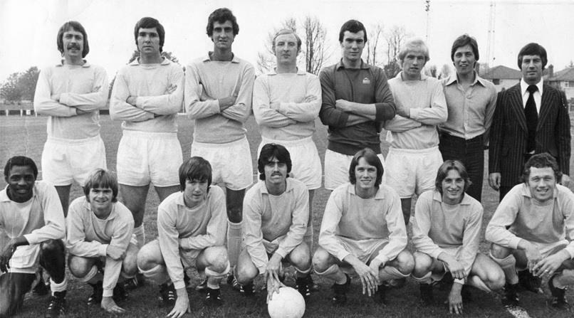
Epsom & Ewell line up on 15th August 1977 for a friendly against Crystal Palace
Back Row: Sos Ferrar, Micky Lyel, Richard Parkin, Tommy McCready, Dick Vincent,
Tony Coombe, Willie Bennett, Pat O’Connell. Front Row: Derek Williams, Kevin Jordan,
Tommy Tuite, Gary Butler, Steve Delaney, Leigh Montgomery, Alan Webb.

Results Grid
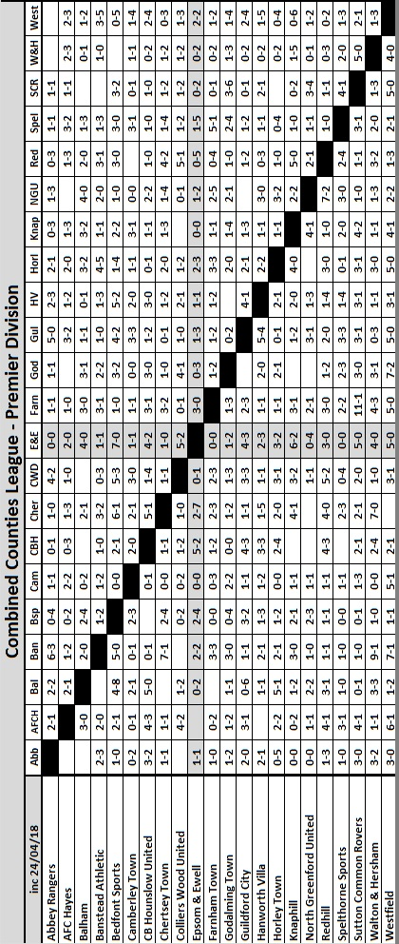

Club Statistical History - (including Walton & Hersham (A) on 24/04/18):
League: Played: 2,922, Won: 1,194, Drawn: 558, Lost: 1,170
For: 5,363, Against: 5,193, GD: plus 170 - Win Ratio 40.86%

CCL only: Played: 501, Won: 220, Drawn: 100, Lost: 181
For: 897, Against: 807, GD: plus 90 - Win Ratio 43.91%

Cup and Other (inc Abandoned Matches):
Played: 1,115, Won: 527, Drawn: 129, Lost: 451 Abandoned: 8
For: 2,418, Against: 2,090, GD: plus 328 - Win Ratio 47.26%

Under Neil Grant: Played 17, Won: 3, Drawn: 7, Lost: 7
For: 22, Against: 31, GD: minus 9 - Win Ratio 17.65%

Total: Played 4,037, Won: 1,721, Drawn: 687, Lost: 1,621, Aban: 8
For: 7,781, Against: 7,283, GD: plus 498 - Win Ratio 42.63%

First Senior Match: 30th August 1924.
Lost 1-3 vs Dorking at our home ground at the time of Horton Hospital Grounds.

First Match Programme Issued: 15th September 1923.
Won 4-0 vs West Norwood Reserves - Friendly match at Horton Hospital Grounds.

Number of Official Home Grounds: Six.

Alexandra Recreation Ground 1918-1922,
Horton Hospital Grounds 1922-1925,
West Street 1925-1993,
Merland Rise 1993-2010,
Moatside 2010-2012,
High Road 2012- present.

Record Win: 12/10/1935 - 13-1 v Reigate Priory (H) - Amateur Cup.

Record Defeat: 14/02/1948 - 0-14 v Chelmsford City Reserves (A) - London League.

Longest Serving Manager: 1) Adrian Hill 853 1982-1985 & 1990-2003
2) Pat O’Connell 466 1973-1982
3) Lyndon Buckwell 407 2006-2014
4) Ricky Kidd 190 1986-1990

Record Appearances: 1) Graham Morris 658 1990-2004
2) Nigel Bennett 630 1989-2005
3) Tommy Tuite 582 1973-1987
4) Ernie Watkins 419 1945-1960

Record Goal Scorers: 1) Tommy Tuite 391 1973-1987
2) Reg Marlow 254 1924-1936
3) Kyle Hough 207 2007-2017
4) Jimmy Jones 148 1933-1945

Most Appearances in a season: Tony Coombe and Tommy Tuite - 59 in 1980/81.

Most goals in a season: Reg Marlow - 65 (at least) in 39 appearances in 1926/27.

Senior League Titles: 5 - 1925/26 Surrey Senior League - 1926/27 Surrey Senior League - 1927/28 London League - 1974/75 Surrey Senior League - 1977/78 Isthmian League Division Two

25 Years ago
On 6th May of this year it will be 25 years since we last played at West Street. A quarter of a Century, just think about that for a moment.

Number 1 at the time was Ace of Base with All that She Wants, while John Major was our Prime Minister and Manchester United were about to clinch their first League title for 26 years! That is all a long time ago now!

We have played exactly 1,258 matches in the 25 seasons since our departure from the Borough, winning 516, drawing 236 and losing 503 with three abandoned matches. We have scored 2149 against 2100, and 618 home matches have elapsed in that time.

Standing: Glen Connett (Committee), Dave Wilson (Secretary), Peter Smith (Director), Andy Nimmo, Tim Tweedy, Dean Meyer (sub), Tony Webb, Graham Morris, Ray Purvis, Richard Strong, Adrian Hill (Manager), Charlie Millard (physio), John Wood (Asst Manager), Peter Atkins (Chairman)
Kneeling: Marcus Alcindor (sub), Nigel Webb, Paul Meredith, Martin Taylor, Nigel Bennett, Glynn Hooper

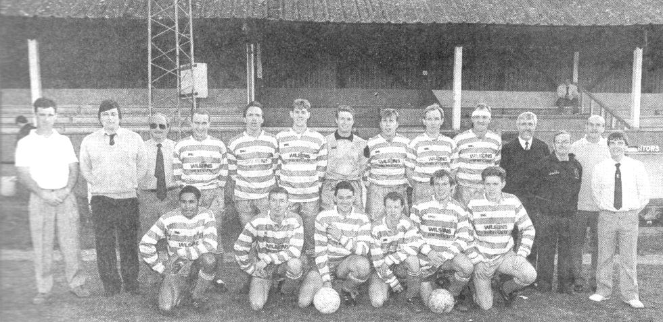
Just looking back at the team line up from that fateful day in our history, none of the players or officials in the photo remain with the club, although surely Dave Wilson would still be here, had he not been taken from us. However, many supporters do still remain from those days.

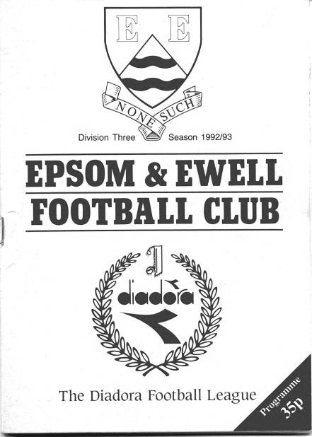
On that final day we were fortunate to host Chipstead, as almost their entire squad and Management had also played for us in recent years. Epsom & Ewell won the match by a goal to nil and the scorer was Paul Meredith. “Merra” is now a diving instructor in Thailand, but he spared the time to let us have a few words:

Former Player - Paul Meredith
I first played at West Street as a 17-18 year old for Epsom and Ewell Reserves in the season we were runners up in the Suburban League to Sutton United (1984/85). I then came back to Epsom in 1992/93 to play for the first team after playing for a number of local teams. Although the changing rooms and ground were getting a bit old and the sloping pitch wasn't exactly like Wembley, it was still a great place to play.

One of the highlights in the last season playing at West Street was hosting Aldershot at home on 17th April 1993 when they came into the league and brought with them a great crowd that created a great atmosphere at the old ground that it hadn't had for many years. I'm sure having that great support was the only reason Aldershot beat us!

Being situated in the middle of the village also brought a few locals into the club on game days and although some may have watched from the bar, while the hardcore fans braved all weathers to stand behind the goal, there was still a feeling that we had supporters and people interested in how we got on.

E&E has always had people involved at the club that had genuine feelings for the club no matter how the team were performing - Dave Wilson and Stella Lamont being two that stand out most to me. Indeed when I first came back to the club Dave talked to me a few times about my time playing in the reserves all those years before. How he remembered one young player that played in the reserves all those years ago always impressed me and said a lot about the man but also about the club he loved.

We had a decent team and good players in the last season at West Street and the next few seasons at Merland Rise and we had a good management team that everybody enjoyed playing under in Ada Hill and John Woods (RIP) but we always seemed to be just a little bit short to push to be among the top teams. It's a shame the new ground didn’t materialise at the time, as I think that might attracted a few new players that would have added the little bit extra we needed to push upwards.

Old age and injuries finally caught up with me and I couldn't train as much as I needed to so my time at Epsom came to an end. I would have loved for the club to have won a trophy or got a promotion but as I said we always gave it a good go, and fell short in the end. That doesn't stop me remembering my time at the club with a lot of fondness.

I dabbled in a little bit of coaching for a while with the highlight being, along with my partner in crime and best mate Gary Wilgoss, leading Tooting & Mitcham Reserves to win the Surrey Premier Cup.

I now live in Koh Samui in Thailand where I am a scuba diving instructor and own a diving centre where we teach people to dive and also to become instructors, and live a life in the sun wearing shorts and bikinis (sometimes the men too; after all this is Thailand!) and enjoying the great food.

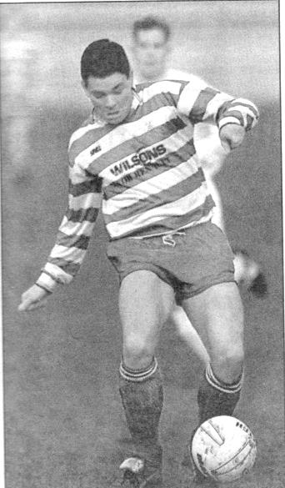
And I do occasionally follow the fortunes of Epsom & Ewell online to see how they are doing and see things are not going so great at the moment, but hope things will turn around as the club and amazing people associated with it deserve.

Paul’s First Team stats for the club: Date of Birth 22nd February 1966 – Debut 18th March 1993
Appearances: 150 plus 10 as sub = 160 (placed 52nd in the Epsom and Ewell FC Hall of Fame)
Goals: 48 (placed 27th in the Epsom and Ewell FC Hall of Fame)

Centre page for results

Centre page for results

AFC Hayes – History
AFC Hayes changed the name of their senior teams from Brook House Football Club at the end of season 2006/2007. The club had been formed in 1974, springing from local Saturday sides Charville and Hayes North.

Success soon followed in the lower divisions of the Hayes and District Sunday League culminating in winning the Middlesex Sunday Junior Cup. Success continued with two League and Cup winning doubles before a switch to Saturday football in 1982 joining the now defunct South West Middlesex League.

Brook House then became founder members of The Middlesex County League before they joined the London Spartan League in 1989 when they were awarded senior status. In their first season, despite not finishing in one of the two promotion spots they were promoted to the Premier Division.

In 1992 the club had their floodlights erected and to mark the occasion, Chelsea were the first opponents under lights at Farm Park. In the same season, the final of the Spartan League Cup was reached, but Cheshunt took the trophy.

With the advent of their lights, the club was able to enter the F.A. Cup, and on two occasions they have reached the first qualifying round, most notably in 1995/1996 when they held Conference side Stevenage Borough to a 0-0 draw away only to lose the replay at home.

In 1997 Brook House appointed Mickey Harvey as manager with the express purpose of linking the Youth and Senior set ups. The move proved very successful as in its first season the club were Spartan South Midlands Premier Division (South) champions.

In 1999/2000 the club were runners up in the Premier Division of The Spartan South Midlands League and were Premier Division Cup winners. At the end of the 2001/2002 season, Manager Mickey Harvey decided to try pastures new, with Bob Strutton taking over.

2003/004 saw all the hard work and belief in younger players pay off, and we were never out of the top three in the league, eventually achieving second place. The lads also won the Challenge Trophy and were runners - up in the Premier Cup. Having just missed out promotion to the new National Step 4, we were invited into the Ryman Isthmian League Division 2.

In the close season, Bob decided to call it a day, so the Club again promoted from within. Joe Mitchell as manager with Colin Murphy as assistant and head coach.

2004/05 was a very good year - 3rd in the league behind Ware and Witham Town and last 16 of the FA Vase. In 2005/6 we won the last ever Isthmian League Associate Members Trophy beating Hertford 3 - 1 in the final. That placing and the E Level ground -grading saw us promoted to the newly -formed Step 4 Level and into The Southern League South & West Division.

After a promising start to the season we had a very indifferent second half, but we managed to achieve our main ambition of staying at this level. The highlight was coming runners-up in the Middlesex Senior Charity Cup.

From 2007-2008 the club started with the new name for our senior sides AFC HAYES. The Youth section are still carrying on our historic club name.

The 2008-2009 Season was the most successful season to date and the team finished 7th in the Southern League. This was overshadowed by winning the Middlesex Senior Cup for the very first time in the club's history. A 2-0 win over Hendon brought the trophy back to Farm Park.

During the next few seasons AFC Hayes consolidated in the Southern League and challenged for the Division One Central play-offs in 2011/12.

In 2012-13 we appointed Ian Crane who rebuilt the team. He was joined by Graham Goode as Assistant but in early December 2014 Graham left us followed by Ian’s resignation after xmas 2014. We appointed Paul Palmer and his assistant Colin Brown quickly, hoping to turn it around but were unable to escape relegation. After an indifferent start to the season with some good and bad results we agreed to part company in November 2015 and Sean Berry a well-known local player took on the role as Manager.

90 years ago!
The 1927/28 season was a very successful season. Following two consecutive Surrey Senior League titles, we took the step up to the London League and won that too! However, it looked like it would be a lot easier at one point and in the end we almost fell over the line.

It was obvious that the step up in standard would also include an increase in travel times and this was made apparent as early as the opening day of the season on 27th August 1927 when we had to journey to East London for a visit to Custom House. They were playing their last season at Bingley Road in West Ham and we secured a fine 4-2 win there, with goals from Jack Parr, Fred Behn, Wilfred ‘Bronk’ Challis and Fred Watts. The latter of these would have a pivotal say in the final match of the season too but more about that later.

Next up was our longest trip in history to that point at Chelmsford in Essex, where we encountered a very large crowd at the time of 2,000 but recovered to net a second half equaliser from Watts in a 1-1 draw.

We edged out Mitcham Wanderers by three goals to two in the FA Cup before hosting another team that were new to the League in Callender Athletic and Reg Marlow and Jack Parr scored twice each as we won this match 6-4 at West Street.

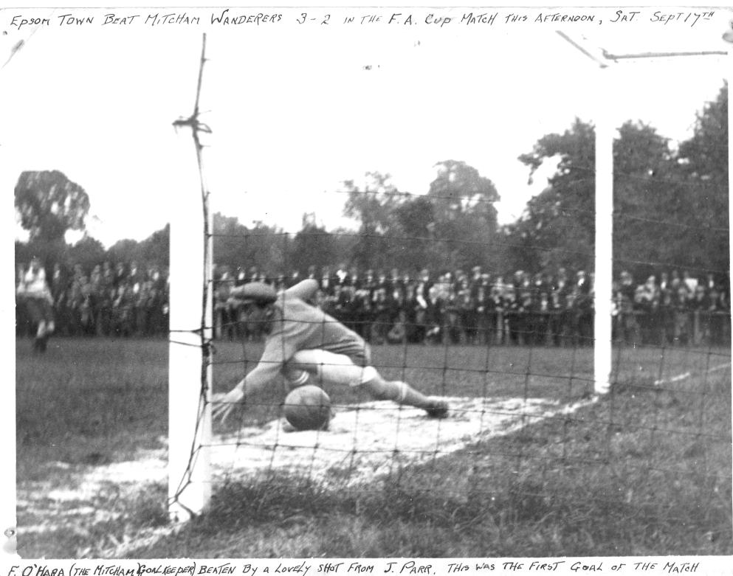
Jack Parr scores our opening goal at home to Mitcham Wanderers in the F.A. Cup at West Street

Our F.A. Cup progress continued as we beat famous old club West Norwood before defeating Sutton United 2-0 at West Street with goals from Marlow and Behn, although we were defeated 3-2 in the Third Qualifying round by Wimbledon at Plough Lane in front of an attendance of 7,631!!

In the meantime we had secured a goalless draw in the return league fixture with Callender Athletic, a works team that were based in Erith, Kent and secured progress in both the Amateur

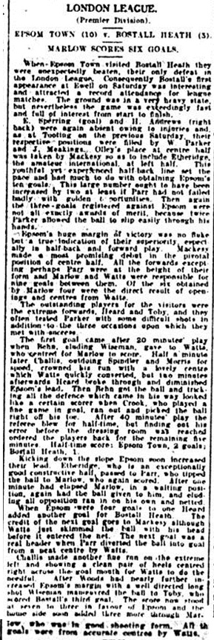
Cup and Surrey Senior Cup.

We made our first ever visit to Bostall Heath, a small area near Welling in Kent, but were defeated 3-0 there to pick up our first defeat of the season and were also dumped out of the Amateur Cup by the Met Police who were a good side back then, going on to reach the Quarter-Final of the Amateur Cup in the not too distant future, so it was no disgrace.

We defeated Aquarius, who were effectively the works team of the Water Board, by a score of 7-3 at West Street but the event was tinged with sadness as founder member Reg Sperring had been offered a dream job as a golf professional in Europe. Both Reg and Ernie were very good at golf and actually lived at the Epsom Golf Club, Ernie would go on to be Captain of the club in 1964 and his picture is on the wall there.

On Christmas Eve we were lucky to draw 3-3 with our new local rivals Carshalton before winning 2-0 at Sandy Lane against Tooting Town. We then avenged our only league defeat in style with a 10-3 victory over Bostall Heath with Reg Marlow setting a new club record with six goals. This would be matched in the future, most recently by Andy Boxall in 1996 but never yet exceeded (see report).

The win over Bostall Heath had taken us to the top of the League and we continued our run with a 2-1 win over Mitcham Wanderers and a 5-1 home win over Finchley. We were on a good run and then won 2-1 at Walthamstow Grange, who prior to the rise in the thirties of the Walthamstow Avenue were the pre-eminent team in the Borough.

We took a break from the League action for a Surrey Senior Cup tie at struggling Summerstown, but they were still a level above us in the Athenian League and won 5-1 in a sea of mud after we had taken an early lead. They were based in Earlsfield but would fold at the end of the season.

Back to League action and further wins followed as we completed a double over Tooting Town and followed it up with a 5-2 win over Custom House. (see programme pictured overleaf)

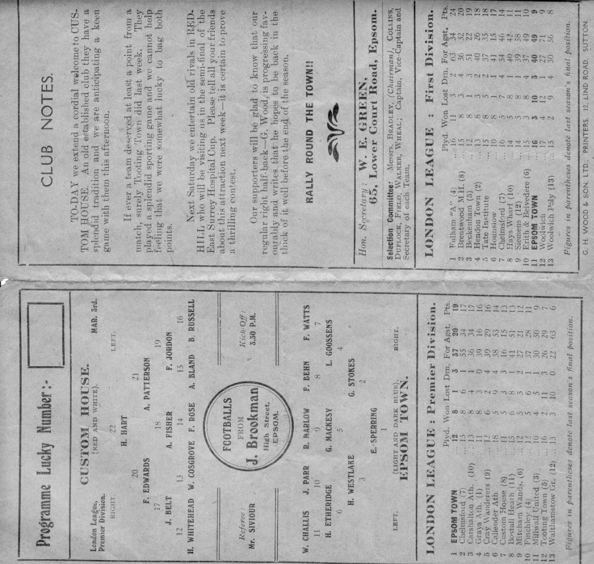
Further wins followed over Chelmsford (2-1) and Millwall United away from home (2-0) with the only points dropped coming in a 2-2 draw at Finchley.

The Easter fixtures gave included a double header with Cray Wanderers who we defeated 3-1 away and then 6-0 at West Street on consecutive days, followed by an Easter Monday win by four clear goals at home to Walthamstow Grange. We were cruising toward the title and 2,000 were present at Mitcham Wanderers old Streatham Road ground to see Epsom win 2-0 against a team that would become their main local rivals over the next few years.

All we needed was two wins from our remaining four matches but suddenly and inexplicably, the wheels fell off. On Saturday 21st April Carshalton Athletic defeated us 2-1 at Colston Avenue, and then seven days later, our main title challengers Grays Athletic ended our unbeaten home League record with a 1-0 victory at West Street.

So now it was crucial. We required two wins from a home midweek match against Millwall United, but even if we were to win that match we needed to visit the Recreation Ground, home of Grays Athletic and win there.

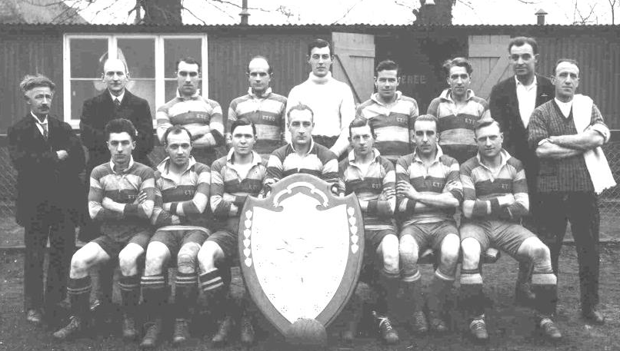
Millwall United were dispatched easily enough by seven goals to three on Wednesday 2nd May 1928 so it all came down to the big match in Essex. Over 5,000 people were there, still the largest ever attendance for a League fixture in our history. The opening exchanges were even but the home team took the lead, with a suspicion of handball in the build-up. However, a few minutes later we were awarded a penalty for a foul on Challis, but Harry Westlake our Club Captain saw his spot kick hit the post!

Luckily it wasn’t too serious and Challis set up Parr who laid the ball on for Watts to score the equaliser before half time.

We were better in the second half, although the opening chance fell to the home side who hit the underside of the bar before the danger was cleared. On such fine margins are titles decided sometimes though and after 52 minutes we were ahead with another smart finish from Watts. We held on to win 2-1 and clinch the London League title for what would prove to be the only time in our history, despite five runners-up places to come in the thirties. Still, this was a great time to be an Epsom supporter and it must have been fantastic to be there.

Combined Counties League Premier Division
Opponents All-time Records
inc Tuesday  24th April | P | W | D | L | F | A | PPG | GD | Best  Win | Worst  Loss
Horley Town | 32 | 21 | 5 | 6 | 71 | 37 | 2.13 | +34 | 6-0 | 1-3
Sutton Common Rovers* | 15 | 9 | 3 | 3 | 30 | 21 | 2.00 | +9 | 4-0 | 0-5
Spelthorne Sports* | 9 | 5 | 3 | 1 | 16 | 11 | 2.00 | +5 | 6-2 | 1-5
Godalming Town | 3 | 2 | 0 | 1 | 4 | 5 | 2.00 | -1 | 2-1 | 0-3
Banstead Athletic | 39 | 23 | 8 | 8 | 64 | 40 | 1.97 | +24 | 5-0 | 0-4
Abbey Rangers | 6 | 3 | 2 | 1 | 12 | 5 | 1.83 | +7 | 7-1 | 2-3
Farnham Town | 17 | 9 | 4 | 4 | 30 | 25 | 1.82 | +5 | 3-0 | 1-4
Bedfont Sports | 13 | 7 | 2 | 4 | 23 | 23 | 1.77 | 0 | 5-1 | 0-7
Colliers Wood United | 25 | 14 | 2 | 9 | 47 | 40 | 1.76 | +7 | 4-0 | 0-5
Westfield | 23 | 12 | 4 | 7 | 45 | 43 | 1.74 | +2 | 6-1 | 0-5
Guildford City | 20 | 11 | 1 | 8 | 39 | 29 | 1.70 | +10 | 5-1 | 1-5
Knaphill | 10 | 5 | 2 | 3 | 20 | 16 | 1.70 | +4 | 4-0 | 2-6
Hanworth Villa | 19 | 9 | 5 | 5 | 42 | 30 | 1.68 | +12 | 5-0 | 1-4
Walton & Hersham | 54 | 25 | 11 | 18 | 105 | 105 | 1.59 | 0 | 8-0 | 1-9
Camberley Town** | 92 | 38 | 24 | 29 | 159 | 126 | 1.50 | +33 | 9-1 | 0-4
Redhill | 35 | 14 | 2 | 19 | 63 | 77 | 1.26 | -14 | 7-2 | 2-8
Chertsey Town | 51 | 19 | 5 | 27 | 77 | 95 | 1.22 | -18 | 3-0 | 0-7
North Greenford United | 14 | 5 | 2 | 7 | 23 | 24 | 1.21 | -1 | 4-0 | 1-4
CB Hounslow United | 5 | 2 | 0 | 3 | 11 | 13 | 1.20 | -5 | 5-2 | 1-5
AFC Hayes | 11 | 2 | 3 | 6 | 18 | 20 | 0.82 | -2 | 7-0 | 0-3
Balham | 2 | 0 | 0 | 2 | 0 | 6 | 0.00 | -4 | x | 0-4
* includes one loss on penalties v Spelthorne and one win on penalties v Sutton Common Rovers
** includes one abandoned match v Camberley

CCL Premier Division Club Directory
ABBEY RANGERS Telephone: 01932-422962 - Colours: Black & White Stripes/Black/Black
Ground: Addlestone Moor, Addlestone. KT15 2QH

A.F.C. HAYES Telephone: 0208-845-0110 - Colours: Blue and White Stripes/Blue/Blue
Ground: Farm Park, Kingshill Avenue, Hayes. UB4 8DD

BALHAM Telephone: 0208-942 8062 - Colours: White & Black/Black/Black

Ground: Colliers Wood United FC - Wibbandune, Robin Hood Way, Wimbledon. SW20 0AA -

BANSTEAD ATHLETIC Telephone: 01737-350982 - Colours: Amber &Black/Black/Black
Ground: Banstead Athletic, Merland Rise, Tadworth. KT20 5JG

BEDFONT SPORTS Telephone: 0208-831-9067 - Colours: Red & Black Hoops/Black/Red & Black
Ground: Bedfont Sports Club, Hatton Road, Bedfont. TW14 8JA

CAMBERLEY TOWN Telephone: 01276-65392 Colours: Red & White Stripes/Blue/Red
Ground: Krooner Park, Wilton Road, Camberley. GU15 2QW

CB HOUNSLOW UNITED Telephone: 0208-577 -9712 Colours: Green/Black/Green
Ground: CB Hounslow Sports Ground, Green Lane, Hounslow TW4 6DH

CHERTSEY TOWN Telephone: 01932-561774 - Colours: Royal Blue & White Stripes/ Blue/ Blue
Ground: Alwyns Lane, Chertsey. KT16 9DW

COLLIERS WOOD UNITED Telephone: 0208-942 8062 - Colours: Royal Blue/Black/Black
Ground: Wibbandune, Robin Hood Way, Wimbledon. SW20 0AA

EPSOM & EWELL Telephone: 01737-553250 - Colours: Royal Blue & White Hoops/Royal Blue/Royal Blue - Ground: Chipstead FC, High Road, Chipstead. CR5 3SF

FARNHAM TOWN Telephone: 01252-715305 - Colours: - Claret & Sky Blue /White/ Claret & Blue
Ground: Memorial Ground, Babbs Mead, West Street, Farnham. GU9 7DY

GODALMING TOWN Telephone: 01483-417520 - Colours: Yellow/Green/Yellow
Ground: Wey Court, Meadrow, Godalming. GU7 3JE

GUILDFORD CITY Telephone: 01483-443322 - Colours: Red & White Stripes/Black/Black
Ground: The Spectrum, Parkway, Guildford, Surrey. GU1 1UP

HANWORTH VILLA Telephone: 0208-831-9391 - Colours: Red & White Stripes/Black/Black
Ground: Rectory Meadows, Park Road, off Hounslow Road, Hanworth. TW13 6PN

HORLEY TOWN Telephone: 01293-822000 - Colours: Claret & Sky Blue/Claret/Claret
Ground: The New Defence, Anderson Way, Court Lodge Road, Horley. RH6 8SP

KNAPHILL Telephone: 01483-475150 - Colours: Red/Black/Red & Black
Ground: Brookwood Country Park, Redding Way, Lower Guildford Road, Knaphill. GU21 2AY

NORTH GREENFORD UNITED Telephone: 0208 422 8923 - Colours: Royal Blue & White/Royal Blue/Royal Blue - Ground: Berkeley Fields, Berkeley Avenue, Greenford, Middx UB6 0NX

REDHILL Telephone: 01737-762129 - Colours: Red and White Stripes/Red/Red
Ground: Kiln Brow, Three Arch Road, Redhill. RH1 5AG

SPELTHORNE SPORTS Telephone: 01932-961055 - Colours: Navy & Sky Blue/ Blue/ Blue
Ground: Spelthorne Sports Club, 296 Staines Road, Ashford Common, Ashford. TW15 1RY

SUTTON COMMON ROVERS Telephone: 0208-644-4440 - Colours: Yellow/ Yellow / Yellow
Ground: Sutton United FC, Gander Green Lane, Sutton. SM1 2EY

WALTON & HERSHAM Telephone: 01932-260300 - Colours: Red & White Trim/Red/Red
Ground: Elmbridge Sports Hub, Waterside Drive, Walton KT12 2JP

WESTFIELD Telephone: 01483-771106 - Colours: Yellow/Black/Black
Ground: Woking Park, Kingfield Road, Woking. GU22 9BA

500 matches in the Combined Counties League
On Thursday of last week at North Greenford United we played our 500th Combined Counties League match. It was technically our 502nd as we have had two abandoned matches, but in terms of official League matches they don’t count!

It seems a long time ago now that we were transferred into the Combined Counties League. Following relegation from the Isthmian League First Division South in 2004 we asked to go into this league, due to the reduction in travelling, but instead were placed in the Isthmian Second Division; a rump of a league for just 16 clubs that were scattered across the Home Counties. Camberley Town, Chertsey Town and Brook House (now AFC Hayes) were our three closest opponents, with regular trips to Clapton, Ware, Witham Town and many others in the North East area of the Isthmian League! We were finally transferred over in 2006 following two extremely inauspicious seasons.

Our Manager at the time was Paul Pritchard, a former player who had come through our Youth team but was having a lot of difficulty in putting a competitive team out when we were technically at the same level as this local league on our doorstep and it was to be hoped that things would improve greatly with the more local destinations to visit.

Unfortunately it didn’t work out like that! Our opening match resulted in a single goal defeat at home to Reading Town and by the time of a 6-1 defeat in late August against Egham Town Pritchard had resigned, probably before he was pushed in truth. Our Coach Peter Augustine took over on a Caretaker basis while we fielded many applications for the role.

Matters were placed on hold on 14th September 2006, following the tragic death of our Secretary Dave Wilson. Some newer followers will not know the amount of time he put into a club that he had been associated with since 1971 and his passing left a huge void for Chairman Pete Lumm and Treasurer Rob Oakes to fill. A minute’s silence was held for Dave at our next league match that took place against Merstham at Moatside (see below).

During this traumatic time the club had to carry out interviews for the new Manager’s position and settled on another former player, Lyndon Buckwell, who, together with his Assistant Tony Coombe has been doing well at Corinthian Casuals in the Suburban League. His first match was a pivotal one on 4th November 2006 at Meadowbank against Bookham who were groundsharing there and

also sitting near the bottom. We recorded our second win of the season that day by three clear goals against a team that was being Managed by a chap called Glyn Mandeville.

Another 3-0 win followed against Cobham three days later (which saw the debut of future Captain Jamie Hatfield) and relegation fears subsided. Over the course of the season there were signs of improvement and a 17th place finish was the result.

In 2007/08 two new strikers made their debuts in Robbie Burns and Kyle Hough. Both would go on to join an elite group of six other players that would score over 100 goals for us, with Kyle reaching 207 in the end and completely annihilating all previous records for penalties. Paul Borg joined us from Leatherhead to provide some stability in goal and the team began to take shape with two players who had joined at the end of the previous season adding a bit of quality in Ben Hayward and Alex Rodrigues, who paired up at the back with newly introduced Charlie West.

There were some fine results, notably a 5-1 home win over promotion chasing Bedfont and a superb 5-3 win at Camberley Town, although results like a home 0-5 defeat to Reading Town showed that we still had work to do and we finished in tenth place.

We required a late Hough equaliser on the opening day of the 2008/09 season to secure a 1-1 draw at home to Camberley Town but a 4-0 win at Guildford City on the following Wednesday set us on our way and we went unbeaten for the first twelve matches of the season to set a new club record. The 12th of these came on 28th October 2008 at Vale Farm, home of Wembley FC.

They were not a great side that season, but we hadn’t won there over many visits since 1962. Despite this, we scored early and led by four goals at the half. With Hough and Burns scoring twice and Dale Marvell scoring the other goal we went top of the league (our first time since the early eighties) as the snow came down, while fireworks went off all around the ground to celebrate the Divali Festival. It was very memorable and I will never forget it, even if four days later we crashed back to earth with a 4-1 defeat at North Greenford United and would not sit at the top of the table for a few years, having to settle for fourth place. Current Captain Alex McKay made his debut for us that season in a tough December match against eventual Champions Bedfont Green.

The fourth place finish earned us a Vase exemption that we would turn into a memorable match in Somerset against Wellington AFC and a Fourth Round appearance at Long Buckby, while we added to the squad. Up front came Mark Jarman, while his former teammate from Bookham Alex McGregor also joined the club, as did future Coach Matt Smith and the talented Ramzi Bedj Bedj.

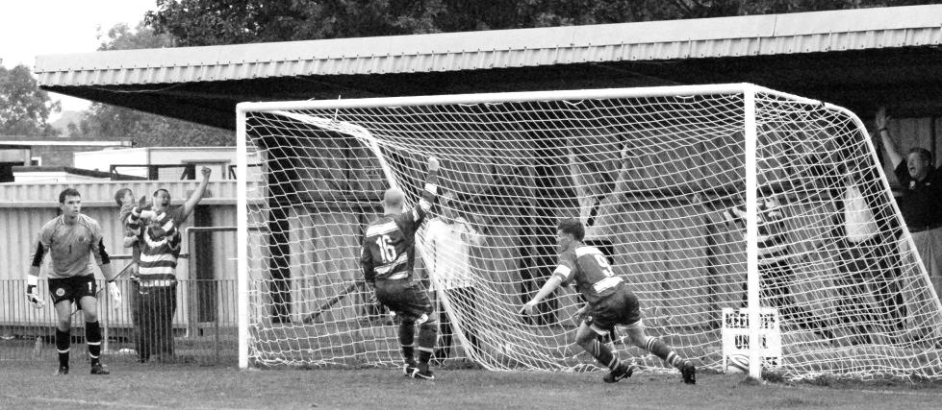
Robbie Burns scores a late winner to complete a 3-2 comeback win over
Chertsey Town on 19th September 2009

In terms of League performances an impressive 6-0 win at Horley Town was the pick while in February Hough scored hat tricks in consecutive matches (the first occurrence of this since 1984) as we won 4-1 at league new boys Hanworth Villa and then 5-0 at Dorking with all the goals in the first half of that match. Ash United were defeated 5-1 as Burns scored 37 goals for the club; the best return for a player since Steve Hill had scored 38, also in our 1983/84 promotion season. Unfortunately, fifth was the final placing, although the club also announced that it was leaving Merland Rise after 17 seasons, still the longest continual temporary ground share at one club in English football history. Buckwell felt that playing at Merstham’s ground in Moatside with the inevitable upgrade in facilities would enable him to get better players to join the club.

Although a couple of players joined in 2010/11 like Tony Cuff and Joe Paris, now at Abbey Rangers, things didn’t improve at all and despite the debut and progression of young defender Anthony Panayi we had to settle for a position of tenth out of 21 and a better record away from home than at Moatside; a pattern that would continue for the following five seasons.

Then for 2011/12 we lost Hough, Marvell and Borg and finally Rodrigues as the season fell apart, not helped by a six point deduction for playing players who had been suspended. Tony Jeffcoate had become Chairman in 2007 following Lumm’s resignation, but we struggled for a Secretary and this was not his strong area. Already let down by Tina Nadesan, (mother of current Football League Professional Ashley, who was in our Youth Team at the time) who had almost been railroaded into the post in the first place, there were administrative issues at the club and nothing would change for a while just yet. We finished 14th out of 22, but when the renewal of our ground share agreement came up we received a better offer from Chipstead which was also slightly nearer to our Borough, and we were on the move again for 2012/13.

Ben Hayward scores the goal of the season with a volley to beat Molesey 1-0 on 1st April 2013

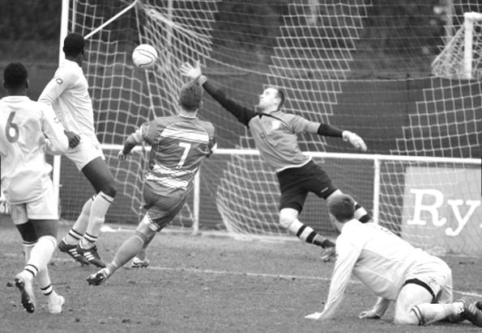
The 2012/13 was significant. Not only was it our first at Chipstead’s High Road ground, but we would win the League Cup 3-0 over South Park at Farnborough and even led the League table,

setting some more club records along the way. It started inauspiciously enough with one point and no goals from our opening three matches but a Mark Jarman goal at Meadowbank ensured our first victory of the season against Dorking and we were on our way.

We won our next three matches but were soundly beaten at eventual Champions Egham Town, for whom both Borg and Rodrigues were now playing, although we returned the favour at High Road in October by two goals to nil. On 24th November 2012 we visited Camberley Town where a 30 yard rocket from Dale Marvell ensured a 2-1 win. What we didn’t realise was that this winning run would keep on going and would eventually reach twelve in a row! We had a couple of narrow squeaks at home to Dorking and then at Chessington & Hook United where we nearly let a three goal lead disappear (as we had done the previous season in an infamous 5-5 draw). However, the twelfth win was the closest of the lot as we led 2-0 only for Raynes Park to equalise through a penalty which resulted in Carl Downs being sent off for an alleged handball. Still Robbie Burns found a way to score a superb winner for the ten men in the 88th minute and although we were unfortunate to see the run end at home to Windsor in the next match, we couldn’t deny that we were a little lucky that it had gone on for so long!

By then we were top of the table, although both Egham Town and new boys Guernsey had games in hand and would eventually overtake us. A 5-2 home defeat to Guernsey ended our realistic promotion hopes even with two clubs going up that year and we eventually found ourselves in fifth place.

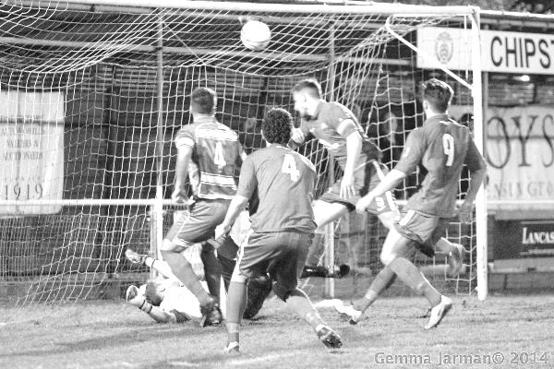
Alex McKay heads a late winner at home to Windsor on 1st April 2014

The players started 2013/14 as if they meant business. Eight straight wins to open the season equalled the record, with the run ending at home to Wembley on a night where our keeper Kieran Campbell was sent off for a professional foul. However, South Park and Camberley Town were also good that year and they gradually reeled us in. There were some good wins; 4-0 over a Colliers Wood team containing a young keeper by the name of Michael Eacott and a 5-1 win at Frimley Green where Nathan Ayling scored and then ended up in goal following injury to Campbell!

However, changes were afoot for 2014/15. Off the field Tony Jeffcoate had been seriously ill and

those who had inherited the job of tidying up the administrational mess found that it made more sense for them to continue looking after affairs. Pete Beddoe stepped up from Vice-Chairman while Steve Dyke became the new second in command.

To make matters more difficult the playing budget had to be cut, which led to the departure of some regulars, but at the same time forced Buckwell to go out and look for replacements. The team he put together were to prove to be almost equally as good, but he never remained to see the project through, resigning in September of 2014. His Assistant Glyn Mandeville was promoted to Manager and the new squad started to settle in. Players like Matt Farrell, Dan Dean, the aforementioned Eacott and defenders Matt Tanton and James Taylor would all prove to be useful acquisitions and they would be joined by Matt Ferdinando in September and then Daryl Cooper-Smith and Agi Panayiotou in January.

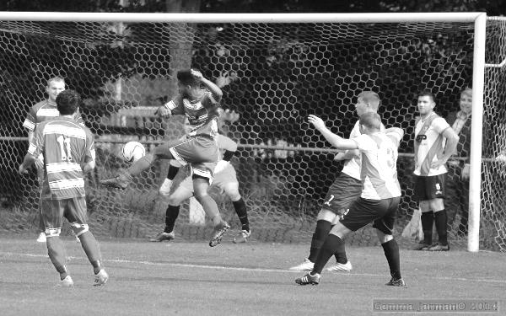
Matt Tanton volleys our goal of the season at Hanworth Villa on 6th September 2014

Although we finished strongly, it had been a slow start as the team took time to gel and the final position of seventh was extremely creditable under the circumstances.

The 2015/16 season was another good one with an end position of fourth place. In addition we team broke several scoring records, particularly away from home where we hit five goals or more in SIX separate league matches, an incredible achievement. We started with a 6-2 win at Spelthorne Sports in September and followed it with a 7-0 win over Cove the following month, but it was in the final months of the season when things really began to happen as Chertsey were beaten 5-3 in March before April contained a 5-1 win at Guildford City and a 7-0 win at AFC Hayes and we ended with a 6-1 win at Chessington & Hook United in May.

Then on 2nd August 2016 we produced probably the most bizarre result in our club’s history when we visited the Orchard, home of newly promoted Bedfont & Feltham in the opening league fixture of the 2016/17 season. We trailed 2-0 at half time yet scored NINE times in the second half to win 9-2!! This equalled our largest ever number of goals in an away match alone, but to do it in the final 45 minutes alone was staggering.

Another newly promoted team Abbey Rangers were defeated 7-1 three weeks later and as Daryl Cooper-Smith racked up 25 goals in his first 21 matches of the season we defeated Bedfont Sports

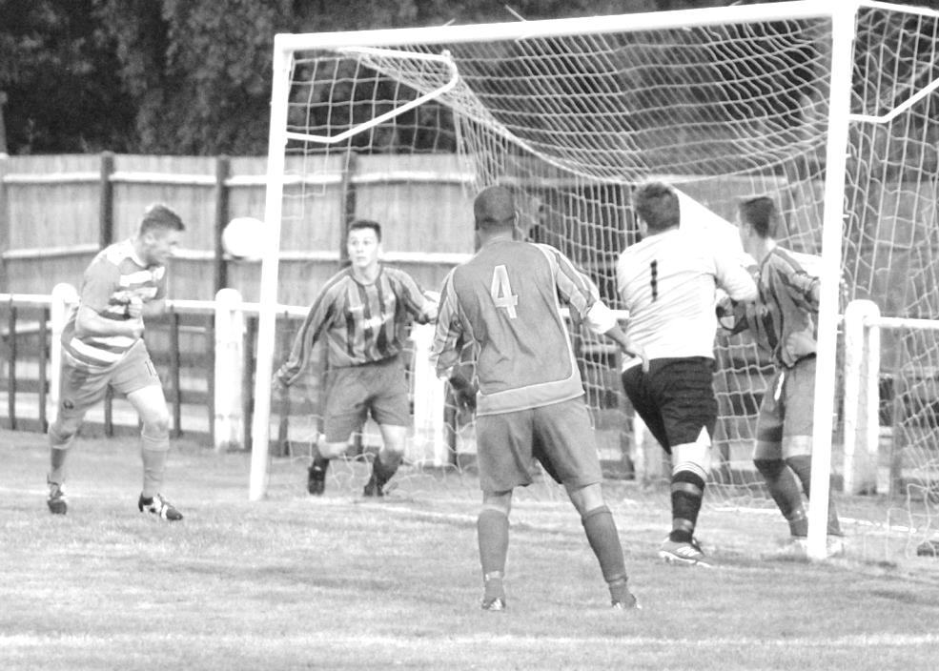
Daryl Cooper-Smith heads our first goal in the incredible come from behind 9-2 win
at Bedfont & Feltham on 2nd August 2016

5-1 and then Worcester Park 6-3 in the League Cup, leading to our appearance in the Final at the end of the season. However, we lost the big matches this year with Champions Hartley Wintney beating us twice, while an improving Westfield also defeated us at Woking Park. Another fourth place was the outcome added to the hope that we could finally go one step better in 2017/18.

Of course we all know now that this wouldn’t happen and the current season is summarised later on in the programme. However, on balance it’s been a fairly successful 500 matches, of which 220 have been won and I don’t think you could find another Step Five club with more wins at this level over the previous five years. Ultimately, all we have to show for it are a League Cup winners and runners-up medal, but on the whole it’s been a fairly good period in our history!

Some Combined Counties League Stats (following the North Greenford match)

First Combined Counties League match: Saturday 12th August 2006 v Reading Town (H) - 0-1
500th match: Thursday 19th April 2018 v North Greenford United (A) - 4-0

Leading Scorer over that time: Kyle Hough - 160
Most Appearances over that time: Kyle Hough - 276 plus 15 sub = 291

Played: 500 Won 220 - Drawn 100 - Lost 180 - For - 897 - Against 803 Win % 44.00%
Manager Records:
Lyndon Buckwell 329 Won 148 Drawn 66 Lost 115 For 576 Against 509
Glyn Mandeville 144 Won 68 Drawn 24 Lost 52 For 282 Against 240
Neil Grant 16 Won 3 Drawn 7 Lost 6 For 22 Against 27
Peter Augustine 7 Won 1 Drawn 1 Lost 5 For 7 Against 13
Paul Pritchard 5 Won 0 Drawn 2 Lost 3 For 10 Against 19
Highest Attendances: (H) 185 - Guernsey 19th March 2013 - (A) 1,271 - Guernsey 5th May 2013,
Lowest Attendances: (H) 19 - Cobham 1st March 2008 - (A) 20 - Bedfont Green 29th March 2008

Every Opponent A-Z
Over the years we have played many, many different opponents. Exactly how many is a difficult question, as it all depends on your definition. Are Camberley & Yorktown different to Camberley Town, or are Epsom Town different to Epsom F.C. or Epsom & Ewell F.C.?

In my analysis I have classed them as the same team, and will work through them all from A to Z. Some we have played many times, whilst others we have met maybe just once or twice. This is the final edition of this series so I will finish off with four clubs this week to complete the set. Enjoy!

Worthing: Played 58 - W29 D8 L21 - F122 A118 - PPG - 1.64 - Above Average

We have been making regular trips to Woodside Road for nearly seventy years. In fact they are seventh on our all-time list of matches played, which always seems strange for a team that we haven’t played since 2003 and that aren’t even in our County!

Worthing had spent their formative years in the West Sussex League and became founder members of the Sussex County League in 1920, but after the Second World War they tried their hand at a better standard of competition and joined the Corinthian League in 1948. As always with Sussex clubs there was a lot of travelling with only Eastbourne at the opposite end of the County as “local” rivals, although in the late fifties they would be joined by Horsham and Dorking, both relatively easy A24 journeys.

We joined the Corinthian League in 1949 and became regular opponents over that time. We first visited Woodside Road on 18th February 1950, losing 0-3 but worse was to follow on 11th March when they won 6-2 at West Street!

It was therefore a complete surprise when on 3rd February 1951 we defeated them by ten goals to nil at West Street with Les Keen and Ernie Watkins securing their only hat tricks for the club, while Sid Faggetter and Bobby Musto shared the other four. True to Epsom form though, we then slipped up 2-1 in the return match, played just four weeks later.

The 1951/52 season was much improved and we registered a pair of 3-1 wins with Bill Goddard scoring five of the six goals and although he also scored in the following season’s matches too, we only won one of them, losing 2-3 in Sussex, although securing a 5-1 win 15 days later. I’m not sure who was responsible for the fixture scheduling but for every season from 1949/50 until 1955/56 we would play our two matches with Worthing in the second half of the season! In 1953/34 we won both matches, but the following season when we finished at the foot of the table Worthing secured their first double over us.

Things changed after Doug Whitehead became our first ever Manager in August 1955 and although our next match ended in a 3-3 draw at West Street on the Easter Saturday of 1956 we won the Easter Monday return 2-1 in Worthing and would go on to win nine and draw two of our next eleven meetings, most notably a 6-2 home win on 24th January 1959 with Reg Carter scoring four times for us.

Following the Christmas matches in 1960 we would have to wait until April of 1962 for our next meeting and by then we were beginning our really poor run that wouldn’t end until 1973 and results started to go in their favour. They defeated us 2-1 and then 5-0 in Worthing in 1961/62 and although we did win in Worthing in October 1962 they returned the favour with an away win of their own just seven days later.

Of course in 1963 the Corinthian League was absorbed within the Athenian League but the story got worse. On 30th November 1963 we suffered a crushing 9-2 defeat at Woodside Road, although we won the return match in February 1964, which was a major shock as we were bottom of the league while they went up in second. In fact, had they won this match they’d have beaten Leatherhead to the title but had to settle for second place.

Their promotion followed by our relegation the following season (we had received a reprieve in 1964) meant that we didn’t meet for a while, although two relegations left them back with us in the Athenian League Division Two for the 1968/69 season. They were still one of the better teams in the division

though, while we were appalling and in our darkest hours. Over the next four seasons we won once, narrowly by the only goal on a midweek Tuesday in August 1969 but lost the other seven meetings and in 1972 they were promoted again.

Worthing’s Main stand at Woodside Road on the site of the old one

As with their previous promotion season we had finished bottom, yet received a reprieve. However, it was a temporary respite and in 1973 we were cast adrift where we received a lifeline from the Surrey Senior League and as all regular supporters know things started to improve from that point.

Although we were not at their level in 1974/75 we were drawn together in the Third Round of the F.A. Vase, where we made a mockery of their two division seniority to win 4-1 in Sussex on 7th December 1974 with Pat O’Connell making his famous statement about checking out the Twin Towers after the match!

Our next meetings came as members of the Athenian League Division One in 1976/77 and we drew 1-0 before O’Connell put a virtual Reserve team in at Worthing to give our boys a rest where they promptly won 1-0 thanks to a goal from the only first teamer who played, Alan Webb. Marvin Hough, Kyle’s dad made his one first team appearance that day, having been a regular Reserve teamer that season.

By this time though both clubs knew that they were on their way into the expanded Isthmian League Division Two and we defeated them 1-0 at home and 3-1 away on the way to the title. Our promotion kept us a division apart for a few years with exception of an Isthmian League Cup tie that we won 1-0 in a replay following a 2-2 draw on the coast. Then in 1981/82 Worthing, under a young Manager by the name of Barry Lloyd won the title and came up to our division, going straight through it and clinching a second title seven points ahead of Harlow Town. We met over the Easter weekend of 1983, beating them conclusively 4-2 on the Saturday thanks to a Steve Hill hat trick, but losing 4-0 in a hailstorm two days later on my first visit to the ground.

We followed them up to the Premier Division the following season and met on 4th September 1984 at Woodside Road. We roared into a 3-0 lead inside twenty minutes and then Colin Miles sent the keeper the wrong way from the spot only to see the ball hit a trailing leg and drop onto the netting behind the goal for a most fortuitous save. Of course, they came back to win the match 4-3 with a 92nd minute back heel. As you do! We did at least have the consolation of winning the return match 2-1 in March 1985 as we comfortably avoided relegation.

The following season we would not be so lucky, although there was revenge of a sort as we went there in March 1986 without a League win away from home to our name. We trailed 2-0 but managed to turn the match around and win 3-2. Our return match ended 3-3 though, which was not enough and two weeks later we were down.

Our only meetings since that time came on a Sunday as we hosted them in an F.A. Cup tie at Merland Rise, losing 3-0 and then in 2002/03 and 2003/04 as members of the Isthmian League Division One South. We went there on the August Bank Holiday after two wins to open the season but as huge underdogs. However, we led 2-0 after a couple of minutes and although they got one back in the second half, we made it 3-1 as Barry Stevens scored his second goal of the match.

The return match came in April 2003 on the night when Adrian Hill announced his retirement. Then Dave Hyatt was injured and midfielder Kevin Webb went in goal as we crashed 5-1. The following season we went down but still registered two draws against them; the first of which came on a midweek in October 2003 with some of our players caught up in a traffic accident on the A23. Matt Sargent made his debut in goal for the delayed Hyatt but a Joel Rogers equaliser gave us a point. Then we drew 2-2 at home in the final meeting between the clubs on 9th March 2004 with goals from Simon Hatton and Ross Shoefield.

When I first visited Worthing’s ground in 1983 it had a great big wooden stand, but this burnt down in the late-eighties and a much grander structure now stands there. They recently converted their pitch to a 3g artificial surface and are currently playing at Step Three in the Isthmian League Premier Division. They continue to attract large crowds and look well set for the future.

Yeading: Played 6 - W2 D1 L3 - F8 A9 - PPG - 1.17 - Below Average

Yeading joined the Isthmian League Division Two South the same year that we joined it, 1987. However, we approached it from different directions as we had just suffered a second relegation, while they had just won the London Spartan League.

Their ground at The Warren was a pleasant one. Well-appointed with a decent clubhouse and facilities, it was a stone’s throw away as the crow flies from the old Southall ground at Western Road. In fact in 1987/88 they would have had a pair of derbies as members of the same league.

Their first ever home league match came against us on 5th September 1987 with our boys being defeated 3-1, although a 0-0 draw in the return denied them a League double, something neither club would ever achieve.

In 1988/89 we won 2-0 at home but were robbed 3-2 in Middlesex as controversial referee Steve Coffin awarded three penalties against us, two of which were scored. Our finest achievement was winning there 2-1 on 22nd August 1989 and although they then beat us 2-1 at West Street in January 1990 it was no disgrace against a team that would win the title and the F.A. Vase that year against Bridlington Town at Elland Road after a draw at Wembley Stadium.

Some of their players had played at Wembley for Southall in the 1986 Vase Final under young Manager Gordon Bartlett (who would go on to spend longer in charge at Wealdstone than Arsene Wenger did at Arsenal) and they would become a very good side, reaching the Third Round of the F.A. Cup before choosing to merge with Hayes to become Hayes & Yeading. Dark days befell the club while the Warren was redeveloped and I can report that they are now settled in their own home as of this season. An enormous grand stand now sits on the site of the old stand and clubhouse and as the pitch has moved slightly, little trace of the old ground remains, except for the covered terracing that used to sit at the top end of the ground.

This now sits forlornly in an overspill car park some thirty yards from the new pitch, overseeing the new ground almost with a sense of sadness that it will never be involved with it. Now back at Step Four but surely destined to rise, they compete in the Southern League where they will meet Westfield next season.

Yeovil Town: Played 2 - W0 D1 L1 - F2 A5 - PPG - 0.50 - Horrible

Huish was one of the most famous venues in English football, even though it belonged to a non-league club. Yeovil Town were famous giant killers in the F.A. Cup and when they were relegated from the Alliance Premier League in 1985 it was the Isthmian League that stepped in, rather than the Southern.

This was exciting news for the other Isthmian League Premier Division clubs, of which we were one. Everyone pencilled in the dates of 23rd November 1985 and 15th March 1986 as their “must see” matches of the season. Of course we were destined for relegation and wouldn’t play them again but we still secured a 2-2 hone draw thanks to a late Dave Taylor equaliser. Dave is father of our former defender James. It was also the first time Epsom had appeared on the Pools Coupon! It would only ever happen twice, but on this day it was rumoured that Dave’s late goal had earned someone the jackpot!

They had some big names playing in those days, including the late Gerry Gow and a young John McGinlay who scored the opener at West Street and they won the return match 3-0 on our day out on the famous sloping Huish ground in front of just over 2,000 spectators. Still they failed to win the title behind Sutton

United and would have to wait a further season before going back up.

It wasn’t all plain sailing though as they lost the ground in 1990 for a superstore and would be relegated again before finding their feet and making their way up to the Football League where they remained giant killers, reaching the Championship recently. And we actually managed to draw with them once!

The main Grandstand at the old Huish ground in the late eighties

Yiewsley: Played 9 - W3 D0 L6 - F12 A25 - PPG - 1.00 - Poor

Most people would have thought that Yeovil would be the last team on this list but in the fifties Yiewsley entered the Corinthian League, stayed a while before moving up, becoming professional, changing their name in 1964 and then folding in 1987, before reforming again. Some clubs have a fascinating history!

Founded in 1872 they joined the Corinthian League from the Delphian in 1954 and we first met on 28th August 1954 at their old ground in Falling Lane, losing 4-0 while they defeated us 4-1 in the return in January 1955 as we finished bottom of the league. In 1955/56 we were stronger and won 4-1 with a Ray Colfar hat trick but again lost there 3-0 in February 1956. In 1956/57 we again won at home but lost away and in 1957/58 we’d lose there twice, 3-0 in the League and 5-1 in the Semi-Final of the League Cup which they would go on to win.

We did get another victory in the last meeting at West Street on 19th April 1958. They were very successful in their time as Corinthians, reaching the First Round of the F.A. Cup in 1956/57 and winning the League title the following season. But as the renamed Hillingdon Borough (in line with local government reorganisation) things got better still, reaching the Third Round of the F.A. Cup in 1969/70, losing after a replay to Sutton United and then reaching the Final of the F.A. Trophy in 1971 at Wembley Stadium where they lost to Telford United 3-2 after being 2-0 up.

They merged briefly with Burnham as times got hard in the mid-eighties after they left their ground, even though it remained vacant for many years before redevelopment, before folding as Burnham reverted to their original name. They then reformed and moved in at the old Ruislip FC ground in Breakspear Lane, very near to Harefield United, but currently play at the wrong end of Step Six in the Spartan South Midlands League with major doubts about their immediate future.

A very sad story, but by no means the only one we’ve encountered over this series and I hope you’ve enjoyed all the tales of clubs we have met.

Seasonal Summary
News about the departing players from our successful 2016/17 campaign started to come through in mid-June when Sutton Common Rovers kindly blew a hole in my summer break by announcing that a couple of players would be leaving us for them.

I sort of knew then that this wouldn’t be the end of the exodus and that this would be a season of struggle. What was more worrying was that our Manager wasn’t too concerned at this stage, with him being pleased to see the back of one unnamed player in particular, and was prepared to wait until pre-season kicked off some three weeks later before proposing to do anything at all.

However, it was apparent even in pre-season that we were up against it. With only Alex McKay pulling on a shirt from last year’s team in the opening friendly we needed a player influx of some quality and it was good to see former Captain Jamie Hatfield bringing in a few of our former players. However, Jamie himself was regularly injured and all of the others couldn’t commit. We had lost our Coach Matt Smith, who was maybe disenchanted with the exodus and coupled with work commitments decided to leave.

However, we had a decent F.A. Cup draw at home to newly promoted Banstead Athletic, so surely we could be in decent shape by the time the season kicked off. With new faces everywhere you looked though, it was hard to be convinced of that fact, even if some of the new players appeared to have some quality about them. From last year’s players, McKay, Rob Hendry, Dan Rose and Reisse Griffin had returned, while Adam Heagney would rejoin about a month into the season and Sam Robinson and former keeper Colin Harris were also back. Throw in the returns of club legends Dale Marvell and of Kyle Hough from Horley, after he had been looking to retire and it appeared a positive situation as we kicked off the season against our local rivals at High Road.

Any optimism that we may have had was crudely blown apart within 50 seconds of the opening match as Banstead took the lead. Although Hendry brought us back on terms with a 9th minute penalty it was clear that we were not as good as they were and it became all about whether we would hang on for a replay. We couldn’t, as a late winner earned the visitors the win. They would go on to defeat Loxwood before losing to another Step Five team in Glebe who lost narrowly to Step Four Phoenix Sports. I couldn’t help but think we‘d have beaten all of those teams, had last year’s side been here still.

Next up was the league opener at CB Hounslow United at their new ground at Green Lane. We started well with a super goal from youngster Joe Loftus-Cheek. He had joined from the Leatherhead Academy along with Ben Dyson, Louis O’Brien and Liam Roberts and all were probably hoping to emulate the successes of Jordan Gallagher and Heagney a season before.

However, this team was not nearly so resilient and we fell away in this match after an injury to our other striker Tayo Ajayi, who limped off the field instead of going down, thus enabling play to continue and leading directly to their equaliser. The score became 4-1 before Hough scored a late consolation but it wasn’t a disgrace. The new side still had much to learn but playing CB Hounslow on the important occasion of their first league match there was always going to be a tough ask.

However, any thoughts that this might be a temporary blip, turned into very loud alarm bells following the next match against Chertsey Town, one of the weaker sides last year. Hatfield returned to the field but was clearly not fit and was withdrawn after just twenty minutes, by which time we had again conceded early, equalised but then fallen away again to trail 4-1. It was 6-1 after just 31 minutes, the earliest that we had ever conceded that many and although matters stabilised for the rest of the match, the final result of 7-2 was still our worst home defeat since a 0-6 loss to Molesey at Merstham in 2012.

Joe Loftus-Cheek opens the scoring for us at CB Hounslow United’s new ground

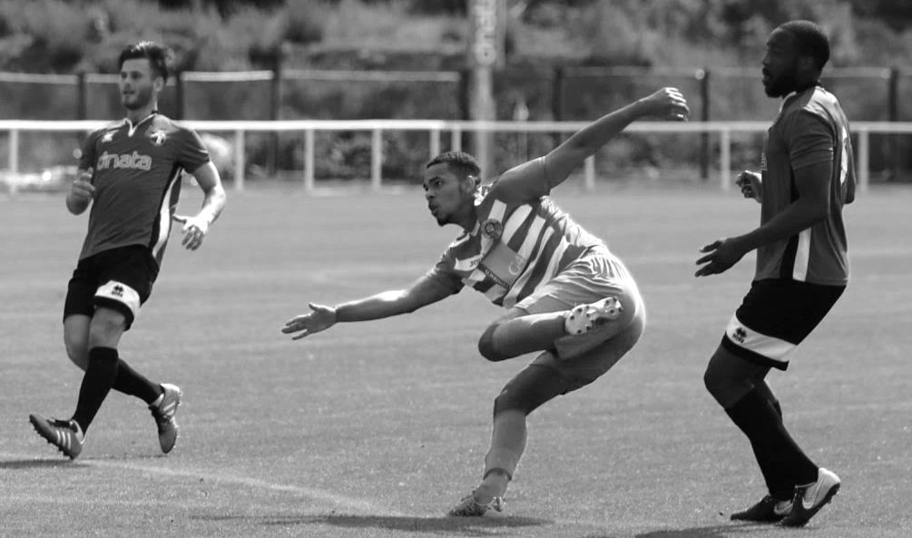
The fixture list decreed that we would visit Sutton Common Rovers early in the season, so following a Saturday off due to our Cup exit we visited them on a Monday night and it must be said were competitive for 40 minutes, but trailed at the half to a soft goal and fell away in the second to lose 5-0 with Daryl Cooper-Smith scoring three times as a second half substitute. We then visited Colliers Wood United on the Friday before the Bank Holiday and again trailed by four goals at the half before losing 5-2. What was particularly concerning at this stage was that SCR apart, we weren’t playing great teams as the League table would confirm as the season progressed.

We nearly secured our first win of the season at Banstead Athletic on the Bank Holiday Monday morning but Kyle Hough’s second half goal was cancelled out by a late equaliser. Still it was a point, and we looked forward to our next match against recently promoted Redhill with confidence that it could be a springboard for the rest of the season. No chance! With half an hour gone we trailed 5-0 again and although this proved to be the final score, I was now really concerned for our survival.

Results continued in a similar vein. The opposition score a few in the first half and then ease off. Spelthorne Sports led 4-0 at half time and as soon as we pulled a goal back they went up the other end and restored the lead. It was as if teams were toying with us, but there were few new players coming in to change matters. A narrow 3-2 defeat at home to Horley Town didn’t tell the story either, which was that our goals both came from keeper errors. Other teams could just step up the pace and we didn’t appear to have a second gear, let alone a top one.

We secured a 0-0 draw at Farnham Town in what was the club’s 4,000th match in history, but in truth they were as poor as us in the match and you sensed that they may also struggle. We then followed this up with a good point from a 1-1 draw at home to Hanworth Villa, with former keeper Michael Eacott in their ranks, before he would visit us again later in the season as a member of Sutton Common Rovers. However, further optimism was then crushed as we bombed out of the League Cup by four goals to two at lower Division Worcester Park. No one knew at the time how good that team would prove to be, but at the time it was now more apparent than ever that the club did something about our situation.

Kyle Hough tucks away yet another penalty in our 6-2 defeat at Knaphill

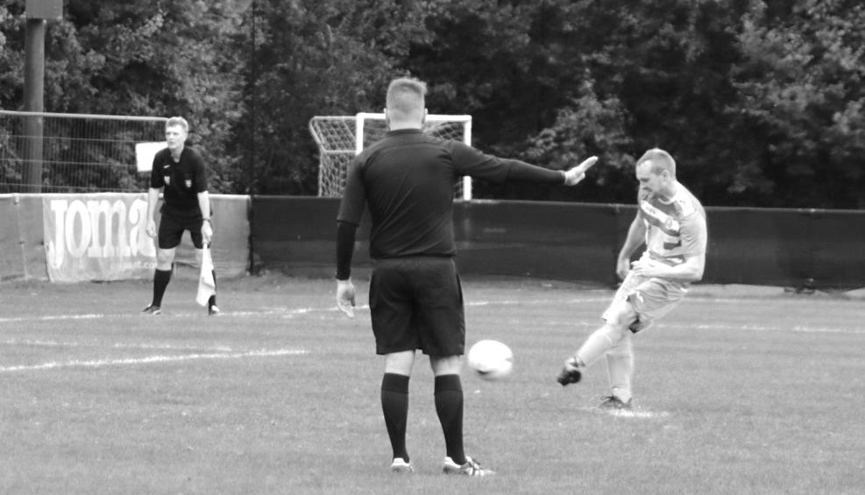
However, a Committee meeting that should have been held after the end of the Worcester Park match to discuss the situation was delayed to the middle of October, by which time we had suffered another heavy defeat, 6-2 at Knaphill. Ashley Thompson scored his first goal for the club that day with a clever finish. He had joined in early September and another new boy Lloyd Connelly would score on his debut at Camberley, where we would secure another 1-1 draw. However, we only had 12 players for that match and it was beginning to look as though Glyn was struggling to get the players to be reliable. Training was not being well attended and the league position was a major concern as teams ever so gradually began to pull away from us.

Finally the club held a meeting to discuss what steps to take. It was decided that Glyn couldn’t do the job to the best of his ability without a Coach, and although he would have the final say on whom to appoint, it was made clear that we needed one within a few weeks. However, the club has always rewarded loyalty here and the decision was made to stick with Glyn for the season, partly because we had an extremely pivotal set of fixtures coming up against the clubs around us and any new Manager would not have time to turn things around in time for those matches.

With hindsight, this was a mistake. Although there was a positive outcome with the appointment of former Leatherhead Academy Manager Neil Grant as Coach from early November, I feel now that we really needed to have made a change of Manager by this time, probably in fact following the Worcester Park loss. Many clubs around us had already dispensed with theirs, but it is a difficult decision to make for a Committee that had never had to deal with this sort of thing before and they were perhaps understandably a little cautious.

Then we went to Rusthall for an F.A. Vase match. Luckily we had gained an exemption to the First Round Proper following our fourth place finish the season before and it was just as well as we would surely not have survived the Qualifying rounds. However, the Kent based team were having a difficult first season at this level following promotion and you never know in the Vase. That was certainly the case on this day as we swept into an early two goal lead with a double from Thompson and although the hosts pulled a goal back and were pushing for an equaliser, they then had a player sent off for a bad challenge.

Then early in the second half Reisse Griffin got possession of the ball deep in his own half. And just kept on running, and running, straight between the defensive pair and through on goal, calmly slotting the ball past the keeper for a really special goal. At 3-1 the opposition fell apart and we ended up winning 7-2! A trip to Whitstable Town awaited us in the next round.

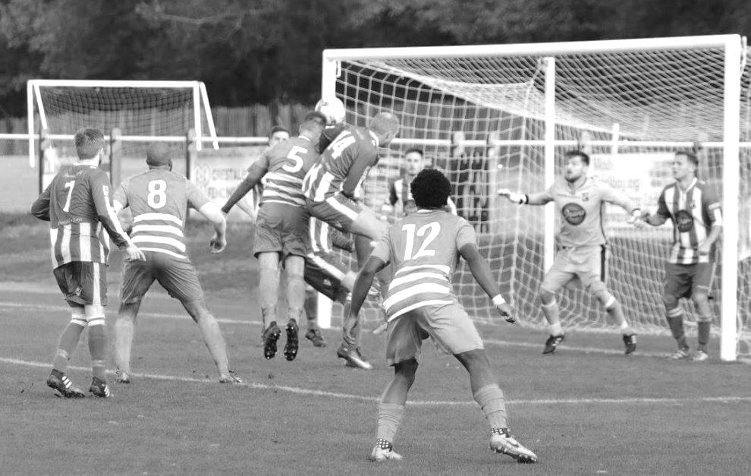
Alex McKay heads our fifth goal in the 7-2 F.A. Vase win at Rusthall

Could we take this into our league form? Regrettably no. New players Taryn Smith and Kane Grandison joined but our next match at home to North Greenford United resulted in another defeat, this time 2-1 with a winner twelve minutes from time. We didn’t realise it at the time but the first half penalty scored by Kyle Hough would prove to be his last for the club as he never played for us again. He is still young enough at 30 to come out of retirement but I would be very surprised if it happened now.

Still, we had shown a bit of heart against the Middlesex team and went to Chertsey Town knowing that a win was probably essential. By this time Conor Young had rejoined the club in goal after a match for us a few years previously and he would prove to be an asset to the club. However, it was his error that led to an early penalty against us this day and despite probably our most dominant performance of the entire season, we had to admit defeat by a goal to nil at Alwyns Lane.

We were then truly dismantled by Bedfont Sports on their new artificial surface at Hatton Road. We had never lost there before, yet were crushed 7-0 by the best team we had faced all season. Then just twelve fit players made the journey to Whitstable Town where we had to admit defeat by 3-2 despite goals from Roberts and Dyson which had taken the tie to extra time. I’m certain that we would have won this important match with a full squad, but any “glamour” tie would have to wait for another season.

We then entered this spell of pivotal fixtures. Farnham Town, AFC Hayes and then Godalming Town lay in wait over the next seven days and three wins would have got us out of danger. We started well with a Roberts double and a third goal from Connelly as we sent Farnham Town packing 3-0. However, at AFC Hayes player reliability issues again came to the fore and despite the match

potentially going either way it was the home side that clinched the points with two late goals. With ten minutes remaining at 0-0 we were technically off the bottom of the table, but the defeat left us there and by the time Godalming had defeated us 3-0 on the following Tuesday we were three points adrift and it would be five further months before we would finally get off the bottom, by which time it would be too late for us to get out of the bottom three.

Those two defeats would eventually extend to eight in the League, approaching a club record, although it was clear that we were becoming a bit more competitive and the turnstile had become closed at the back. A move to place Adam Heagney in the centre of the defence helped and he was paired with either McKay or Griffin over the next few matches with new signings Endrit Dobraj and Noah Stew-Lewis battling it out for the full back slots, before Stew-Lewis received a Scholarship to play football in the United States.

Then finally on 13th January we broke the run with our first away league win of the season. Godalming Town had thrashed us 3-0 in November but we needed a response at Wey Court and got it. Despite conceding early, I felt we were harshly behind and an equaliser before half time from new signing Kyen Nicholas and a winning goal from another player making his debut, Marlon Pinder gave us a 2-1 win. It was the first time since the opening match of the 1987/88 season that two debutants had scored for us and Grant’s new players were beginning to make a difference.

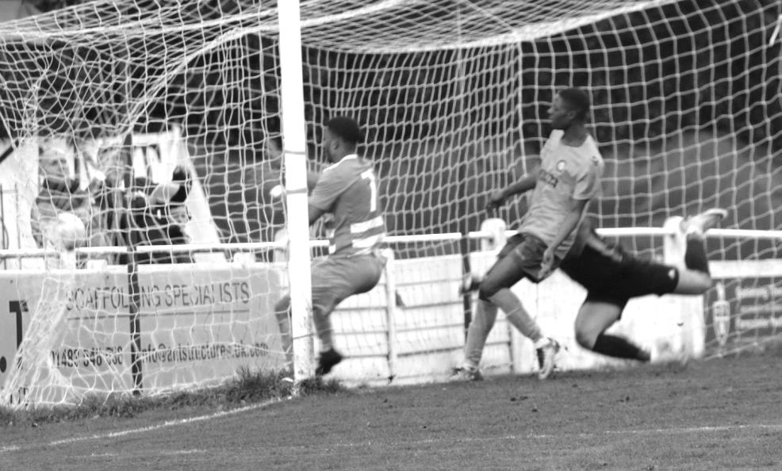
Marlon Pinder scores our winning goal at Godalming Town in January

Although Mandeville was Manager for this match, it had become obvious to many that the new additions were coming in through the Coach and with the knowledge that our Manager had advised the Committee that he would be leaving at the end of the season, it became clear that it would make far more sense to let the Coach take the reins for the rest of the season. The theory was twofold. Quite obviously Neil would have a chance at getting the club out of the hole they were in, but also he would get the opportunity to learn the role, having never Managed at this level before, and this would give him the chance to prepare for the new season, where we would hopefully be in a position to bounce straight back up, should we go down.

This fairly clear cut and sensible suggestion was somewhat surprisingly not taken on board by the

whole Committee and in the end it took Mandeville’s resignation after the Godalming match before an offer for Grant to become Caretaker Manager was forthcoming.

Our new man in charge faced a baptism of fire with a visit from Isthmian Premier League Merstham in the Surrey Senior Cup. During our run of eight league losses we had secured a goalless draw at Sutton Common Rovers, who fielded many of their Reserves in this match and they paid for that decision as we advanced on penalties with five superbly struck kicks to their four. Unsurprisingly Merstham won 5-0, but the match was even for the first half hour as we gave as good as we had got against a full strength Merstham team that had taken a draw from big spending Billericay Town the week before.

More new players joined, as well as a Coach, Jordan Clark, who was connected with the Dorking Wanderers Academy. The team was reshaping and was showing a nice mix of youth and experience. Potential? Definitely, but would it be enough to get us out of the hole we were in?

Well, there was a clear improvement, especially at the back as we tightened up considerably. Two draws followed against Abbey Rangers and Spelthorne Sports and although we lost narrowly to our old boys when Sutton Common Rovers visited in February, we secured a 3-2 win at Hanworth Villa and the Committee decided to remove the Caretaker tag from Neil’s title as a direct result of this.

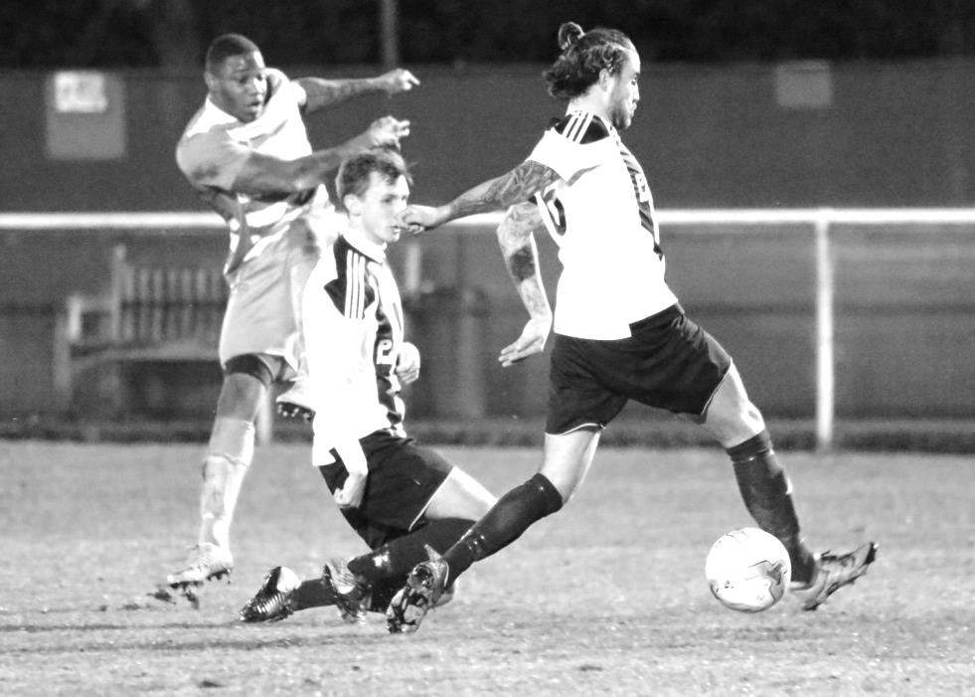
Kyen Nicholas puts us ahead against Abbey Rangers in January

Unfortunately, whilst we were now much more competitive now, we still had a large hole to climb out of and despite securing three goalless draws in a row against Abbey Rangers, Knaphill and Camberley Town, the latter two of which were in good form, we just weren’t able to secure the wins that might have got us in touch with the clubs above us. When Balham defeated us 2-0 at High Road we found ourselves well adrift with our hopes pinned totally on picking up six points from our upcoming Easter fixtures against Colliers Wood United and Banstead Athletic.

We found the net twice in our next fixture against promotion chasing Bedfont Sports, despite losing 2-4, but threw in a poor performance against Colliers Wood United on Good Friday and although we got a 2-2 draw at home to Banstead Athletic a few days later we had to face the fact that survival was now out of our hands.

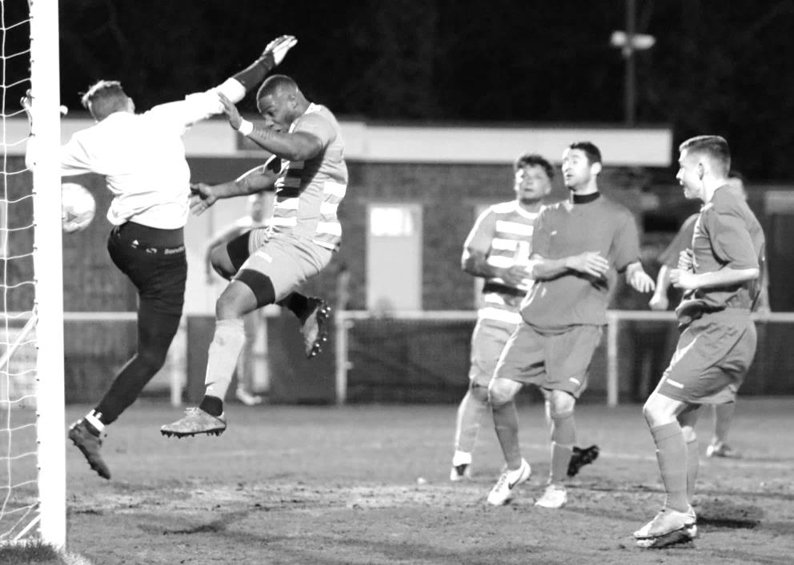
Kyen Nicholas puts us 2-0 up against Banstead Athletic on 7th April 2018

A 3-4 defeat at Guildford City followed on the Saturday after this before we hosted Champions Westfield who had won their last 17 league matches. Despite trailing 2-0 though, we fought back to secure a draw with two goals from Loftus-Cheek who almost had a hat trick but was denied by a great save.

He found the net again three days later as we again had to recover from two goals behind, but this time we turned it around completely against CB Hounslow United to win 5-2 with strikes from five different scorers, although it was a strange finish as the visitors had only brought twelve men and actually finished with nine due to injuries by the end. It should be pointed out that we were already 3-2 ahead before they lost their first man.

Two days later we won again, this time battering North Greenford United into submission with an impressive first half display which ended explosively with four goals for our boys in the final six minutes of the half. Louis O’Brien scored his first goal for the club, then two minutes later he had scored his second! The second half probably should have seen us concede a couple but it’s not our fault if the opposition don’t take their chances!

After a Saturday off we visited the Elmbridge Hub for the first time to play Walton & Hersham and we were a shadow of the team that had performed so well a few days previously, losing 4-0 but in Walton & Hersham we were up against a much higher standard team who looked very dangerous.

So we approach the finalé of the season today and few will mourn its passing. It is to be hoped that we have all learned from this chastening experience and are better prepared as a result, even though relegation means that our club has paid the ultimate price for its lack of action.

Farewell, Au revoir, Auf Wiedersehen, Adieu….
So it’s finally happened. After a tenure of 12 years in the Combined Counties League Premier Division, which was the joint second longest of any club behind Colliers Wood United, we have had to accept relegation to Step Six football, the lowest level we have played at since 1923/24. It is to be hoped that like back then we will have just one season at that level. If that were the case it could be argued that we aren’t saying goodbye to the Premier Division, just au revoir and see you soon!

So what will happen next season? What else does playing at that level entail? Firstly, we should still be able to enter the F.A. Cup next year, although with the number of extra clubs now playing at the Step Four level there will either be less extra-Preliminary Round ties or an extra round. If it is to be the former, which appears likely, then we will have to ensure that we finish well up the division or we may not be able to enter it in future years, as was last the case back in 1972/73.

There will also be a question over our participation in the Surrey Senior Cup. Ok, it may not be a particularly high priority these days, but we had entered it every year it had run since 1924/25 so it will be sad to break the sequence if we are unable to take part. I’m sure I recall Dorking entering it following relegation to Step Six a few years back, but this year Raynes Park Vale did not, so it is possible we will be faced with the Surrey Premier Cup instead. We will of course remain in the League Cup and will additionally be participating in the Division One League Cup too, while our entry in the F.A. Vase will remain as before.

Some might say that because the standard will be lower that we ought to be able to bounce back up to Step Five and they may well be right. Badshot Lea have done exactly that this season. However, Bedfont & Feltham and probably Raynes Park Vale too have not and they both went down with a better record than we have had this season. The Division is littered with clubs that haven’t bounced back like Chessington & Hook, Frimley Green, Ash United and of course Cove to remind us that there are no certainties in football.

Make no mistake, the club is committed to returning to the top flight as soon as possible.

Obviously this has been a horrible season for supporters to endure and we as a Committee have, I hope, learned a lot too. It’s comparatively easy to run the club when everything is going well, but faced with the loss of a number of players, we simply didn’t react quickly enough and for that, on behalf of the club, I apologise to all of our regular faces out there.

We really didn’t spot the danger signs early enough and even when some did, nothing was done for far too long. By then it was too late for Neil to do too much about it and he also found the going tough in what must be remembered is his first spell in Management at this level, although recent results suggest that a promising 2018/19 may follow.

Neil had never Managed at this level and mistakes will inevitably be made. This was one of the reasons why I was the prime mover in letting Neil have a good run at the job this year, once we knew that Glyn was not remaining with the club beyond the season’s end, so that he got the chance to experiment and “find his feet” for want of a better term. He is still learning that the particular requirements of a senior club are different to the Academy structure he came from, in particular with an understanding of what is required on the Media and communication front, but I am confident that he will learn this and that he is the

right man to be given a fair chance next season to bring us back to Step Five.

It is to be hoped that he is able to retain the players we have and strengthen further over the close season. Neil currently advises that he believes all of our players will remain, but Step Six is a drop down and twelve months ago Glyn Mandeville would have said exactly the same thing and we know what happened there, so we’ll just have to wait and hope.

Our Committee now numbers six, as it did last year. We have made the decision to remove the club Manager from Committee responsibilities, although he will report back to us from time to time throughout the season. In addition to Chairman Pete Beddoe, Treasurer Steve Dyke, myself, kit man and Hospitality Officer Paul Marshall and Membership Secretary Mel Tough we have welcomed Gary Jarman into our ranks. Gary has been a regular supporter for nine seasons now, joining when his son Mark was a playing member, and was thrown right in at the deep end with all the Managerial discussions almost as soon as he joined.

However, I shall dispense with tradition this year and not thank any of them. None of us on the Committee are deserving of thanks this year. We are all at least partially responsible for the club’s relegation and all of us have to look at our roles over the course of every season and assess whether we could have done better, and that is never truer in a season like this. With responsibility comes accountability and whilst many on the Committee spend an enormous amount of time working for the club, we need to work smarter, not harder. We didn’t, and as such are responsible for the position the club finds itself in.

However, if this sounds like I am being critical of the Committee, this is only half the story. I am actually being critical of EVERY SINGLE adult Salts supporter out there. If mistakes have been made at Committee then at least the people who have stood for those positions have done so with a genuine desire to want to do something to help the club. It is a thankless task at the best of times and we really need many more of you to offer to come on board and help make the sort of decisions which may benefit the club.

Let me make this clear too. You DO NOT have to be a regular supporter. Although we will always welcome help on home match days, it is the strategy of the club that needs a complete re-visit and frankly it is not that important if you only get to half a dozen matches as long as you can attend the meetings which tend to be once every six weeks or so. To this effect, if you have business experience, either from working high up in a Company, or running your own business, or have experience in marketing or sales, please get in touch. There are so many little things that could be done that would benefit the club, but that would take up time that myself, Pete and Steve in particular do not have available.

That also goes for the Programme and reports. I have been doing these for eleven years and have received many awards and compliments, but my work circumstances are changing, so will have much less time to do them. I spend many hours trying to raise the club’s profile by way of Social Media and more relevantly the website, and I think it has gone well on balance.

I still get grief at times for stating the facts, but I do it because I believe that the supporters were left in the dark far too much in my earlier years here and should know what is happening. I won’t “rose-tint” something as that way you’ll always get honest and open reports from me and where relevant, criticism too, but that doesn’t mean I can’t stand down if someone else can do it better, or even to a similar standard. In fact I’ve just handed over the match day announcements to one of our new young supporters Sam Dyke as he does a better job at it than I do.

In a perfect world I would love to be sitting down (as I’m getting older!) at a new ground, beer in hand, watching our team rise up the divisions to the level I feel we should be playing at, and not having to worry about what tasks I need to do after the match, or who just assisted for that goal, or the substitution we just made. That should be the task of the younger generation, but we don’t have one. That group of people in their twenties and thirties just don’t exist here anymore. We are paying a heavy price for the loss of our ground and this is one of those issues that aren’t immediately noticeable until you look around.

The only good news on the horizon relates to one of the suggestions that I put forward towards the end of 2016/17, which was that we should re-visit the idea of the Hook Road Arena as a ground option. The two sites near NESCOT had fallen through and we were looking at no other options and a bleak future. The original idea had been passed on due to the potential loss of revenue to the Council should we move there, that we could obviously not afford to reimburse. However, it occurred to me, fairly obviously when you look back at it now, that we could co-exist there on a portion of the site without any loss to them.

We have now progressed that idea to the extent that it forms the basis of our current proposal which is to be discussed by the majority Residents Association on the Epsom & Ewell Borough Council on 14th May. Maybe, just maybe this could be our route back home.

Realistically that has been our only highlight during a pretty dismal Centenary season and so my thanks are limited too. I shall start with someone who is not here anymore and that is Glyn Mandeville. Glyn did a good job in his time with us as Assistant and then as Manager. Circumstances overtook Glyn very early in the season and if there was a fault on his part, it was only that a lack of contacts meant he was unable to redress the problem. His success and hard work over the previous seasons should not be forgotten.

I will also thank Gemma Jarman our excellent club Photographer. She hardly misses a match and gets so many of our goals on camera at a time when those have been in short supply! Gemma also administers our Instagram site which has many followers and appears to be the Social Media app of choice for the younger generation these days. Additionally, Jeff Pye took some pictures of certain matches and they are all available on the club website, listed at the foot of this page, while George Holland now sends brief reports in to the local papers. Additionally, I thank those loyal supporters that have remained during this season and like you, hope that we will have more to celebrate next season, both on and off the pitch.

I will finish by thanking our Landlords Chipstead F.C. and can confirm that we have signed a new two year agreement to remain at High Road. This at least provides us with the facilities that we may desire, if not the playing level and we also know that the Chipstead Sponge will continue to ensure that very few of our matches bite the dust.

Enjoy the break, and the forthcoming World Cup, but please give some thought over the summer to what YOU can do for the club. If you are in doubt, come and ask a Committee Member and we can try to match you up with any particular skill set you may have.

This club can be a great one again, representative of a town our size. I believe that once we can get a ground back in the Borough we can really progress, but it will need a lot of people to help our cause. It’s actually a very exciting time to get involved and I genuinely remain hopeful while the Hook Road Arena option remains on the table. The alternative doesn’t bear thinking about.

Match and Ball Sponsorships – 2017/18
Opponent | Date | Match Sponsor | Ball Sponsor
Banstead Athletic (FAC) | 06/08/17 | Club President - Stella Lamont
Chertsey Town | 15/08/17 | EEFC Management Committee
Redhill | 02/09/17 | Building Shop Ltd
Spelthorne Sports | 09/09/17 | In memory of Betty Dyke
Horley Town | 12/09/17 | Alex McKay (Senior)
Hanworth Villa | 23/09/17 | Jack Jarman
North Greenford United | 28/10/17 | Marvin and Kathy Hough
Farnham Town | 14/11/17 | In memory of Dave and Lizzie Marshall
Godalming Town | 21/11/17 | Building Shop Ltd
Guildford City | 02/12/17 | John Bonner
Walton & Hersham | 30/12/17 | Jeff and Arnold Pye
Merstham (SSC) | 16/01/18 | Paul Merritt
Abbey Rangers | 23/01/18 | Pete Beddoe’s grandchildren  George, Joseph, Ezara & Inaya
Sutton Common Rovers | 03/02/18 | David Ellins
Knaphill | 24/02/18 | Jack Jarman
Camberley Town | 10/03/18 | Pete Lumm
Balham | 13/03/18
Bedfont Sports | 24/03/18 | EEFC Management Committee
Colliers Wood United | 30/03/18
Banstead Athletic | 02/04/18 | Nathan Lambert – 10 years old today!
Westfield | 14/04/18
CB Hounslow United | 17/04/18
AFC Hayes | 28/04/18 | Club President - Stella Lamont
Match sponsorship costs just £60.00!

Sponsorship includes:

Admission, programmes and hospitality for three people.

A full page advert in the programme and mascot for the day (if required).

Also, you get to choose the player of the match, who will receive a prize

If you are interested, just speak to a Committee Member,
or drop me an email at: richard.c.lambert@gmail.com

Salts Super Six Predictor
The Salts Super Six Predictor jackpot is now at £159 for today’s final match. The tickets are on sale to the left of the gate and the matches are to be played today!

The competition is easy to play! To win, you simply need to predict the results of six matches correctly from the three options, fill in the form and make sure it is back with our seller before the deadline on the ticket. The latest fixtures are shown below.

If you are a club regular, you just need to place your name on the sheet, although if you aren’t, then we’ll need a contact number from you too. We will announce any winners on the website within three working days, so don’t worry, we won’t miss you!

Please note that if there is more than one winner, the prize pot would be shared between the winners. All you need to do now is have a go, as many times as you like!

Instead of showing the ticket today I thought I’d show a few of our winners over the season, many of whom have come from Sabre Insurance Company, whose staff have really bought into this competition.

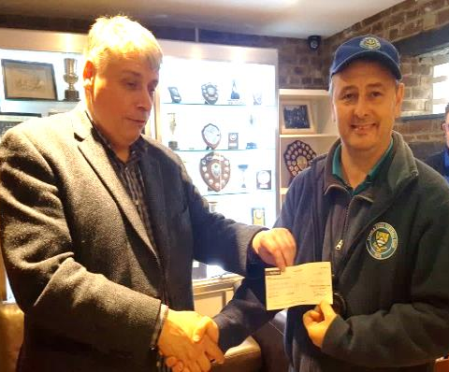
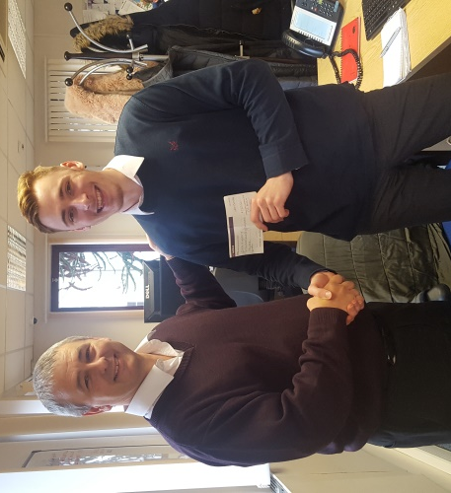
From top left and clockwise: Russell Bateup, Richard Lambert, Danielle Fidler, Charlie Kingsbury
Thank you!

Combined Counties League – Premier Division
Saturday, 28th April 2018 - Kick-off 3.00 p.m.
Epsom and Ewell  (Royal Blue & White hoops) | V |  | AFC Hayes  (All Yellow)
Squad | NUMBERS |  | Squad
Conor Young |  |  | Cameron Kennedy
Endrit Dobraj |  |  | Ryan Dearden
Shaun Masterson |  |  | Haluna Masemba
Adam Heagney |  |  | Kieran Cathlene
© Alex McKay |  |  | Max Benicasa
Ashley Thompson |  |  | Ryan Phillips
Reisse Griffin |  |  | Spencer Maw
Scott Murphy |  |  | James Charles
Kyen Nicholas |  |  | Mourad Jarraz
Marlon Pinder |  |  | Daniel McDonnell
Ben Dyson |  |  | Dean McDonnell
Lloyd Connelly |  |  | Ronnell Dennis
Liam Roberts |  |  | Ndovi Lusungu
Miguel Anderson |  |  | Ollie Jones
Ben Franklin |  |  | Charlie Cahill
Josh Burt |  |  | Bradley Hand
Stuart Russell |  |  | Max Hubbard
Elliott Thompson |  |  | Darreon Mark
Alvin MacAuley |  |  | Johan Rennemo
Rory Sellick
Neil Grant | MANAGER |  | Alan Galloway / Dave Kennedy
Alex McKay | ASSISTANT
 | COACH / PHYSIO |  | Ciprian Pintilie
REFEREE: L.Torz-Brown
ASSISTANTS: D.Merrick, M.Stevens
Today’s Match and Ball are kindly sponsored
by our Club President, Stella Lamont

Thank You for your support this season!

See you in August 2018!

